**MasterCook**

**Group No: 1**

**Student:**

|  |  |  |
| --- | --- | --- |
| **No** | **Full Name** | **Student ID** |
| **1** | **Nguyen Viet Hung** | **SE62279** |
| 2 | Vo Gia Vu | SE62267 |
| 3 | Tran Trong Hieu | SE62260 |

**Table of contents**

Table of contents 2

**Review 1** 3

* 1. Introduction 4
  2. Existing Scenario 4
  3. Customer Requirement Specification 4
  4. Functional Requirement Specification 5
  5. System Requirements 9
  6. Development Software 9
  7. Technology 9

**Review 2** 10

* 1. Use Case and Sequence Diagram 11
  2. Entity Relationship Diagram (ERD) 73

**Review 3** 78

* 1. Database Relationship Diagram 79
  2. Table Definition 80
  3. Other Constraint 86
  4. Site map 88
  5. GUI Design 90
  6. Report 166

**Task sheet** 170

Task sheet 171

**Monitoring Report** 174

Unit Test 175

**REVIEW 1**

1. **Introduction**

**MasterCook** is an organization founded by YoungChefs, a group of young successful cooks in Vietnam. they always think of how to serve best meals for customers, as a result, they are insearch of new favorite recipes.

In early days, they started to found a club of cooking lover. As it turns out, cooks had a huge appetite for sharing recipes; the club was an instant success. Over a few years later, YoungChefs wanted to expand the club and social network allowing cooks of all types and interests to connect through recipes, cooking tips, personal collections, and more. What started with a single cookie recipe has grown organically to become the large food-focused social network with a community of over 50 home cooks consuming more than 1000 recipes.

“Everyone can cook”, that is the slogan of YoungChefs. They want to share all the recipes of meals for passionate people and make an online magazine about food. This is the idea of **MasterCook.**

1. **Existing Scenario**

The club of cooking lovers founded by YoungChefs has been showed many disadvantages. The number of members in the group is one of them, YoungChefs can not handle and manage such a large quantity of cooks every offline meetings.

Besides, all the knowledge made by this club is not organized and shared with every members as well as all people in Vietnam. Moreover, as more than 1000 recipes are made, that is really difficult to store and find out one of them.

Finally, YoungChefs decides to make an online club, which is a website that always upload news and recipes for everyone to have access to newest cooking knowledge.

# Customer Requirement Specification

The website contains new recipes of these young cooks and collaborators, as well as some best suggested restaurants to customers, besides that, the website provides some up to date cooking news.

Guest who visit web-site firstly will see the home page. The home page contains a banner on header for our introduction. Guest will see the latest posts and pinned posts at first.

Guest can choose to see posts by choosing categories from a menu. Besides, they can search to see posts by name.

When guest see post in detail, they can see some related posts, related news. They are also able to leave their comment, which will see directly after they submit.

***If a user log in, there are 4 roles: collaborator, employee, manager and administrator. Notice that they can not register for new account, they must contact page if they want to be a collaborator.***

* **Collaborator**

Main task of collaborator is posting news to web-site, collaborator can only upload posts in the category they are assigned, which will be reviewed by employee. Each post must have required following informations such as title, date, author, etc.

Collaborator can search their own posts which were accepted, and these post at first will show in order of latest to oldest. Collaborator can see which posts are still pending, which post were rejected. The rejected posts come with the reason why they were rejected.

Collaborator can edit the post if necessary. Besides, they can check and delete comments in the post.

Collaborator can see their own profile. They can see some information of their supervisor such as the contact, name, etc.

* **Employee**

Employee can do everything that collaborator do.

Employee can also review posts of collaborator. Employee have the right to review their collaborator’s posts, reject it or accept it. The posts which are accepted by employees will be passed to manager for final review before showing in web-site. If employee rejects task then they are required to add reason why the post is rejected.

* **Manager**

Manager will receive posts which are accepted from employees. These posts will be reviewed finally by manager.

Manager can reject post with some following reason why the post were rejected. Manager can accept post and then the post will be shown in web-site at the begin of the home page as the latest new.

Manager have the right to create new employee or collaborator. Besides, they are able to edit information of collaborators and employees.

Manager can see their own profile and some information about administrator, their supervisor, such as the contact, name, etc.

* **Administrator**

After logged in, administrator will see the main page for his tasks.

Administrator can manage categories of posts. He can remove existed one from web-site, update, or insert new category.

Administrator can manage all staff account such as create new account, delete account, update information of account, change role.

# Functional Requirement Specification

***4.1. Search posts for user***

**4.1.1.Description**

Guest type in a text box to search for the title of post they want to see. If search box empty, do nothing. Having no result then show an announcement, else display posts in order of date from latest to oldest.

**4.1.2. Functional Requirements**

REQ-01. A search text box and a submit button

REQ-02. All searched posts must be not in deleted status.

REQ-03. Category of the posts must be not in deleted status.

***4.2. GUI attractive***

**4.2.1. Description**

System should provide to Guest an attractive home page.

**4.2.2. Functional Requirements**

REQ-01. An attractive home page

***4.3. Select category of posts from menu***

**4.3.1.Description**

Guest chooses options in menu and subcategory in each option.

After choosing specific category, all post belong to this category will be displayed in order of date and the priority state.

**4.3.2.Functional Requirements**

REQ-01. A menu bar

REQ-02. All displayed categories must be not in deleted status.

REQ-03. All displayed menu options must be not in deleted status.

REQ-04. All displayed posts must be not in deleted status.

***4.4. Leave comment in a post***

**4.4.1.Description**

Guest will type his comment into a text area. After click submit, a form for guest to enter info of guest like :

- name

- email

- phone

- gender.

**4.4.2.Functional Requirements**

REQ-01. A text area for guest to type comments.

REQ-02. A form to fill informations of guest. Form have fields

-name

- email

- phone

- gender radio button.

REQ-03. After send comments, the current page will be updated.

REQ-04. Comment will be checked before being shown in web.

***4.5. See detail of post***

**4.5.1.Description**

When guest click a post, the post’s detail will be shown with the following structure:

* header
  + title
  + author
  + date modified
* body
  + text
  + images
* footer
  + related post
  + comments

**4.5.2.Functional Requirements**

REQ-01. increase view of post implicitly.

REQ-02. The post must be not in deleted status.

REQ-03. The related post is same sub-category with the current post.

REQ-04. The comments must be not in deleted status.

## ***4.6. Collaborator can post articles to system for pending***

### **4.6.1.Description**

System must provide for Collaborator an upload page. In this page, Collaborator can edit their articles and submit. Submission should provide these information:

1. Title
2. Content (text/picture)
3. Category
4. Subcategory

### **4.6.2.Functional Requirements**

1. Collaborator must provide :

- title

- text

- pictures

- category

- sub-category

1. Minimum amount of pictures is 2, maximum is 10
2. Title is unique
3. Submission must be sent to Employee

## ***4.7. Collaborator can view their own articles***

### **4.7.1.Description**

System must provide for Collaborator an article management page. Collaborator can view their article list in order latest to oldest by default and can sort by status:

- accepted

- pending

- rejected

The rejected articles come with the reason why they were rejected. Collaborator can choose to view an article

### **4.7.2.Functional Requirements**

1. System must provide Article Management page for Collaborator, they can view their article list in order latest to oldest
2. Collaborator can sort their articles by status
3. Collaborator can view the reason of rejected articles
4. Collaborator can choose an article in the list to view

## ***4.8. Collaborator can edit their articles***

### **4.8.1.Description**

In Article Management page, Collaborator can choose to edit their articles except pending status articles. Modified articles are changed status to pending and sent to Employee

### **4.8.2.Functional Requirements**

1. Collaborator can edit their articles
2. Modified articles are changed status to pending
3. Modified articles must be sent to Employee

## ***4.9. Collaborator can delete comments in their articles***

### **4.9.1.Description**

When viewing their own article, Collaborator can disable comments in their articles

### **4.9.2.Functional Requirements**

1. Collaborator can disable comments in their articles

## ***4.10. Management of Collaborator***

### **4.10.1.Description**

System must provide for Collaborator a management page

### **4.10.2.Functional Requirements**

1. Collaborator can modify their profiles

***4.11. Employee can review posts of collaborator.***

**4.11.1.Description.**

Employee can view pending posts of collaborator in the specific subcategories he/she manages. Employee has to read and decides to approve the post or reject it. After approving the post, it will be passed to manager.

**4.11.2.Functional Requirements.**

REQ-01. Employee can view list of new pending posts.

REQ-02. Employee can approve or reject the pending posts.

REQ-03. Employee can edit post immediately if necessary.

REQ-04. Employee must have a reason why the post is rejected.

***4.12. Manager can review posts after they are passed by employees.***

**4.12.1.Description.**

Manager can view pending posts of collaborator in the specific category he/she manages. Manager has to read and decides to approve the post or reject it. After approving the post, it will be on the website as latest news.

**4.12.2.Functional Requirements.**

REQ-01. Manager can view list of new pending posts.

REQ-02. Manager can approve or reject the pending posts.

REQ-03. Manager can edit post immediately if necessary.

REQ-04. Manager must have a reason why the post is rejected.

***4.13. Manage accounts.***

**4.13.1.Description.**

Manage and administrator can manage account of employees and collaborators, include:

* View how many accepted posts, pending posts and rejected posts of collaborator.
* View how frequent that collaborator have a new post.
* View the average views and comments each post of collaborator.
* View how many posts accepted and rejected by employee.
* View how frequent that employee check a new post.
* View the average views and comments each post approved by that employee.
* Create new accounts for employees, collaborators and managers, include:
* First name
* last name
* user name
* password
* phone number
* email
* date of birth
* address
* gender
* working categories
* role. (Only administrator can create account for managers)
* Edit information of employees, collaborators and managers, include:
* First name
* last name
* password
* phone number
* email
* date of birth
* address, gender
* working categories
* role. (Only administrator can edit information of managers)

**4.13.2.Functional Requirements.**

REQ.01 Must have an interface for managing accounts.

REQ.02 All fields in creating and editing accounts must be validated:

* First name and last name must not be empty.
* User name is unique.
* Password must have 6-32 characters.
* Phone number must have 10-11 numbers.
* Email must have right format.
* Gender must be checked.
* Can have more than 1 subcategories or empty.
* Role must be checked as
* collaborator
* employee
* manager (manager can only be checked by administrators).

***4.14. Administrator, manager manage posts***

**4.14.1.Description**

Administrator and manager after logging in can modify all posts.

**4.14.2.Functional Requirements**

REQ-01. System provide a page for modifying the post.

REQ-02. System provide a form with all attribute which are allowed to be modified.

REQ-03. Some post’s attributes can be modified is:

* the title
* Post’ state:
  + accepted
  + pending
  + rejected
  + deleted
* The modified date is automatically updated to current date after they click submit changes.
* The priority.

REQ-04. If some attributes that manager not allow to modified it will be disable.

***4.15. Administrator manage subcategories***

**4.15.1.Description**

Administrator after logging in can modify all subcategories, include add new, edit and remove.

**4.15.2.Functional Requirements**

REQ-01. System provide a page for modifying the post.

REQ-02. System provide a form with all attribute which are allowed to be modified.

REQ-03. Some subcategory’s attributes can be modified is:

* the name
* state:
  + active
  + deleted
* The category in which this belongs to.

***4.16. Making statistics for Administrator***

**4.16.1 Description**

System provides many options for administrator to make statistics based on all web-site’s activities.

**4.16.2 Functional Requirements**

REQ-01. System provides a menu for administrator to choose options for what statistics he want.

REQ-02. There’s a option for total posts of web-site in a specific time such as:

* total accepted post of web site from date X to date Y.
* total rejected post of web site from date X to date Y.
* total pending post of web site from date X to date Y.

REQ-03. There’s a option for finding out list of posts based on number of views in descending or ascending order in a specific time.

# System Requirements

## ***5.1. Hardware***

### **5.1.1.Web Server**

|  |  |
| --- | --- |
| Processor | Pentium IV or higher. |
| Memory | 512MB RAM or greater. |
| Modem/ADSL | Connecting to internet 24/24 |

### **5.1.2.Client**

|  |  |
| --- | --- |
| Processor | Pentium III or higher. |
| Memory | 64MB RAM or greater. |
| Monitor | Super VGA (800x600) or higher resolution with 256 colors. |
| Pointing Device | Microsoft Mouse, Microsoft IntelliMouse®, or compatible pointing device. |
| Modem/ADSL | Connecting to internet |

## ***5.2. Software***

### **5.2.1.Web Server**

|  |  |
| --- | --- |
| Operation System | Windows 2000/XP/2003 |
| Browser | Internet Explorer 6.0 or higher. |
| Database | Microsoft SQL Server 2008 |
| Software | Java SDK |
|  | Apache Tomcat |

### **5.2.2.Client**

|  |  |
| --- | --- |
| Operation System | Windows XP or later. |
| Browser | Internet Explorer 6.0 or higher. |

# Development Software

* Microsoft Windows 10
* Netbeans 8.2
* Java SDK
* Apache Tomcat
* Microsoft SQL Server 2008
* Google Chrome

# Techonology

* J2EE
* Java Web Service
* JSP, Servlet
* HTML

**REVIEW 2**

***8.1 Guest***

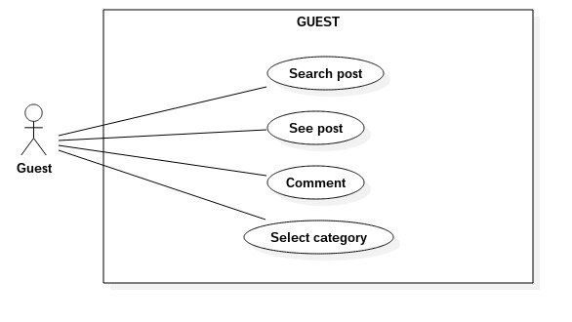

**8.1.1 Search posts**

|  |  |  |
| --- | --- | --- |
| **Author** | Tran Trong Hieu | |
| **Use Case Name** | Search posts | |
| **Actors** | Guest | |
| **Description** | Guest wants to search posts by typing to search text box. | |
| **Requirements** | Guest types texts into search text box.  Search text box is available in all guest’s accessible page. | |
| **Pre-conditions** |  | |
| **Post-conditions** | Success: Guest see a list of posts whose title contains the typed string.  Fail: “No Result” announcement or  Do nothing if search box is empty. | |
| **Basic flow** | Actor Actions:  2. Guest input post’s title into search text box.  3. click “Search” button to submit | System Responses:  1. System displays “home.jsp” page contains:  - Posts  - Menu  - Search text box  - “Search” button  4. System use text in Search text box as post’s title to query DB. [Alternative 1]  5. System displays ‘guestSearchResult.jsp’ page which contains results in a grid. Each result contains:  - an image  - title  - Date created  [Alternative 2] |
| **Alternative flow** | Actor Actions: | System Responses:  [Alternative 1]  1. If Actor click “Search” button with empty Search text box, System do nothing.  [Alternative 2]  1. System display in ‘guestSearchResult.jsp’ page contains a message:  - ‘No Result Found’ |
| **Exception** |  |  |

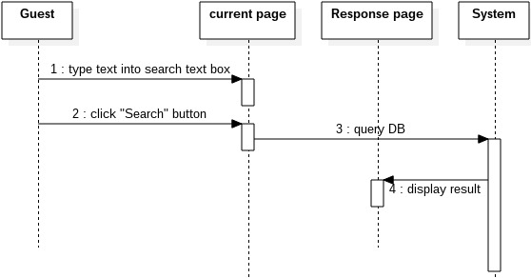

**8.1.2 See posts**

**8.1.2.1 View post’s detail**

|  |  |  |
| --- | --- | --- |
| **Author** | Tran Trong Hieu | |
| **Use Case Name** | View post’s detail | |
| **Actors** | Guest | |
| **Description** | Guest view contents of the post | |
| **Requirements** | There is 2 hyper link at image and post’s title.  Guest click to image or post’s title | |
| **Pre-conditions** |  | |
| **Post-conditions** | Displays contents of selected post, the related post, and the comments | |
| **Basic flow** | Actor Actions:  2. Guest click the hyper links of post. | System Responses:  1. System displays list of posts. Each post has:  - an image (hyper link)  - title (hyper link)  - modified Date  3. System take post ID from the clicked link.  4. System queries DB to take post location.  5. System reads the post’s contents into the ‘articleDetail.jsp’ page.  6. System display ‘articleDetail.jsp’ page. |
| **Alternative flow** |  |  |
| **Exception** |  |  |

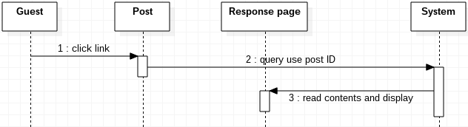

**8.1.2.2 View same Sub-category posts**

|  |  |  |
| --- | --- | --- |
| **Author** | Tran Trong Hieu | |
| **Use Case Name** | View same sub-category posts | |
| **Actors** | Guest | |
| **Description** | At the right of the current viewed post will display some posts having same sub-category with the current post. | |
| **Requirements** | Sub-category of the current viewed post | |
| **Pre-conditions** | Guest click to see contents of a post. | |
| **Post-conditions** | List of posts having same sub-category of the current post. | |
| **Basic flow** | Actor Actions:  2. Guest click the hyper links of post. | System Responses:  1. System displays list of posts. Each post has:  - an image (hyper link)  - title (hyper link)  - date created  3. System take post ID from the clicked link.  4. System queries DB to take post’s sub-category.  5. System queries DB take random 5 post.  6. System return result and display ‘articleDetail.jsp’ page. |
| **Alternative flow** |  |  |
| **Exception** |  |  |

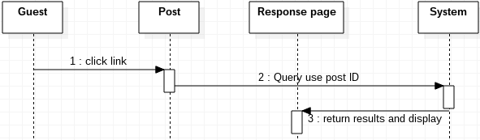

**8.1.2.3 View post’s comments**

|  |  |  |
| --- | --- | --- |
| **Author** | Tran Trong Hieu | |
| **Use Case Name** | View comments of post | |
| **Actors** | Guest | |
| **Description** | Guest see comments below the post. | |
| **Requirements** |  | |
| **Pre-conditions** | Guest click to see contents of a post. | |
| **Post-conditions** | Display all comments belong to the post | |
| **Basic flow** | Actor Actions:  2. Guest click the hyper links of post. | System Responses:  1. System displays list of posts. Each post has:  - an image (hyper link)  - title (hyper link)  - modified Date  3. System take post ID from the clicked link.  4. System queries DB to take all comments and guest information.  5. System return list of comments. Each comment will have:  - Name of the guest comment  - The contents  - Comment time  6. System display ‘articleDetail.jsp’ page. |
| **Alternative flow** |  |  |
| **Exception** |  |  |

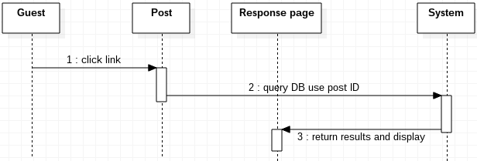

**8.1.3 Select Categories**

|  |  |  |
| --- | --- | --- |
| **Author** | Tran Trong Hieu | |
| **Use Case Name** | Select Categories | |
| **Actors** | Guest | |
| **Description** | Guest click categories in the menu or the link | |
| **Requirements** |  | |
| **Pre-conditions** |  | |
| **Post-conditions** | Display list of posts having the clicked category. | |
| **Basic flow** | Actor Actions:  1. Guest click the name of category, which contains a hyper link. | System Responses:  2. System take the category name and query posts.  3. System return results and display ‘sameSubCatArticles.jsp’ page. |
| **Alternative flow** |  |  |
| **Exception** |  |  |

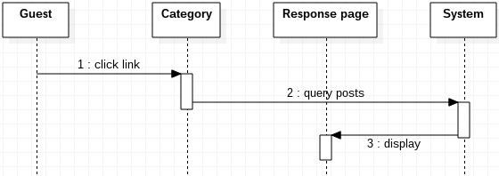

***8.2 Administrator***

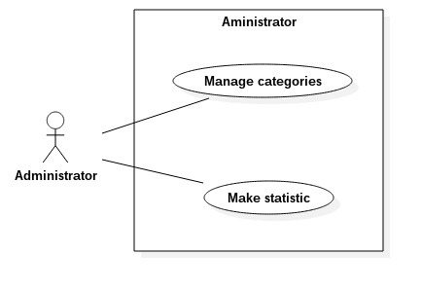

**8.2.1 Manage sub-categories**

**8.2.1.1 Add new sub-categories**

|  |  |  |
| --- | --- | --- |
| **Author** | Tran Trong Hieu | |
| **Use Case Name** | Add Sub-Category | |
| **Actors** | Administrator | |
| **Description** | Administrator add new sub-categories. | |
| **Requirements** | Administrator input sub-category’s information | |
| **Pre-conditions** | Administrator has logged in | |
| **Post-conditions** | Success: New sub-category added and appear “Add successfully” announcement  Fail: appear “Add Fail” announcement. | |
| **Basic flow** | Actor Actions:  1. Actor choose “Add category” option on menu  3. Actor inputs information and click “submit” button. | System Responses:  2. System displays ‘addSubCat.jsp’ page with form contains:  - ‘Name’: a text field for sub-category’s name  - ‘Parent-category’: a combo box contains name of all active category.  - A submit button.  4. System check information [Exception 1]  5. System reload current page with an announcement “Add Success” at the top of page. |
| **Alternative flow** |  |  |
| **Exception** | Actor actions:  [Exception 1]  1. Actor left ‘Name’ field empty  2. ‘Name’ is existed. | System Response:  System display message:  - ‘Sub-Category name is required’  - ‘Sub-Category name is existed’ |

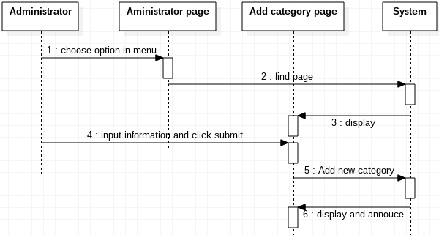

**8.2.1.2 Modify sub-category’s field**

|  |  |  |
| --- | --- | --- |
| **Author** | Tran Trong Hieu | |
| **Use Case Name** | Modify Sub-Category | |
| **Actors** | Administrator | |
| **Description** | Administrator want to change attributes of sub-category | |
| **Requirements** | Administrator input informations. | |
| **Pre-conditions** | Administrator need login first. | |
| **Post-conditions** | Success: Update the current page  Fail: Reload page without any change | |
| **Basic flow** | Actor Actions:  1. Actor choose “Modify category” option on menu  3. Actor inputs information and click “submit” button. | System Responses:  2. System displays ‘modifySubCat.jsp’ page has list of all categories in form of a table contains columns:  - ‘No’: row number  - ‘Name’: a text field for sub-category’s name  - ‘Parent-category’: a combo box contains name of all active sub-category.  - ‘Is Active’: a check box  - ‘Update’: a submit button.  4. System check information [Exception 1]  5. System update DB  6. System reload current page with updated table |
| **Alternative flow** |  |  |
| **Exception** | Actor actions:  [Exception 1]  1. Actor left ‘Name’ field empty  2. ‘Name’ is existed. | System Response:  System reload the current page without any change. |

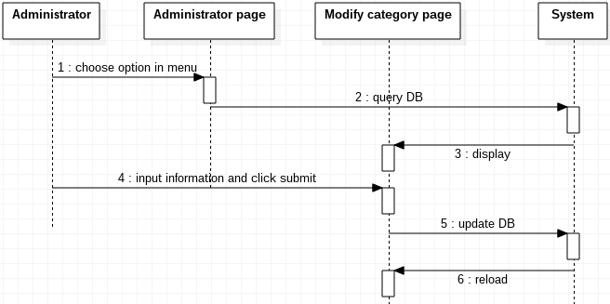

**8.2.2 Make statistics**

**8.2.2.1 View total post in amount of time**

|  |  |  |
| --- | --- | --- |
| **Author** | Tran Trong Hieu | |
| **Use Case Name** | View total post by state | |
| **Actors** | Administrator | |
| **Description** | Administrator the quantity post in two specific time in 3 groups:  - total of accepted post  - total of rejected post  - total of pending post | |
| **Requirements** | - The begin time  - The end time | |
| **Pre-conditions** | Administrator must login | |
| **Post-conditions** | Success: Administrator see the total of post in 3 group.  Fail: Display message “No Result” | |
| **Basic flow** | Actor Actions:  1. Actor choose “Make statistics” button on menu  3. Actor choose ‘Total article by state’ option in menu of ‘makeStatistic.jsp’  5. Actor inputs begin date, end date and click ‘submit’ button. | System Responses:  2. System display ‘makeStatistic.jsp’ with a menu:  - ‘Statistic article by view’  - ‘Total article by state’  4. System display ‘totalPostByState.jsp’ page with:  - ‘Begin time’: a text box  - ‘End time’: a text box  - a submit button  6. System check information [Exception 1]  7. System query DB  8. System displays 3 groups have the total post:  - total of accepted post  - total of rejected post  - total of pending post  [Alternative 1] |
| **Alternative flow** | Actor actions: | System Response:  [Alternative 1]  1. System have no result between specific times and return a message “No result” in ‘totalPostByState.jsp’ |
| **Exception** | Actor actions:  [Exception 1]  1. Actor left ‘Begin time’ field empty  2. Actor left ‘End time’ field empty  3. Actor enter wrong format of date  4. Actor enter not valid date:  - not valid day in month  - not valid month  - not valid year | System Response:  1. Display message ‘begin time required’.  2. display message ‘end time required’  3. display message ‘Date format is: YYYY-MM-DD’  4. display message ‘date not valid’ |

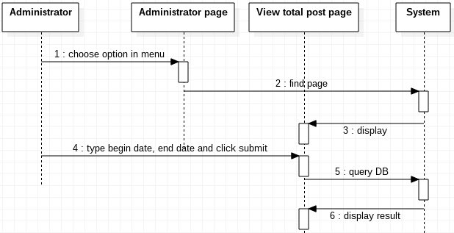

**8.2.2.2 View list of post ordered by descending total numerous views**

|  |  |  |
| --- | --- | --- |
| **Author** | Tran Trong Hieu | |
| **Use Case Name** | See list of post by view number | |
| **Actors** | Administrator | |
| **Description** | Administrator see a list of posts in order of descending total views in 2 specific times. | |
| **Requirements** |  | |
| **Pre-conditions** |  | |
| **Post-conditions** | Administrator see a list of posts in order of descending total views | |
| **Basic flow** | Actor Actions:  1. Actor choose “Make statistics” option in menu  3. Actor choose ‘Total article by state’ option in menu of ‘makeStatistic.jsp’  5. Actor inputs begin date, end date and click “submit” button. | System Responses:  2. System display ‘makeStatistic.jsp’ with a menu:  - ‘Statistic article by view’  - ‘Total article by state’  4. System display ‘listPostByViews.jsp’ page with:  - ‘Begin time’: a text box  - ‘End time’: a text box  - a submit button  5. System check information [Exception 1]  6. System query DB  5. System displays result in table has:  - entry number  - title  - author  - date created  -Date last modified  - Category  - View number  [Alternative 1] |
| **Alternative flow** | Actor actions: | System Response:  [Alternative 1]  1. System have no result between specific times and return a message “No result” |
| **Exception** | Actor actions:  [Exception 1]  1. Actor left ‘Begin time’ field empty  2. Actor left ‘End time’ field empty  3. Actor enter wrong format of date  4. Actor enter not valid date:  - not valid day in month  - not valid month  - not valid year | System Response:  1. Display message ‘begin time required’.  2. display message ‘end time required’  3. display message ‘Date format is: YYYY-MM-DD’  4. display message ‘date not valid’ |

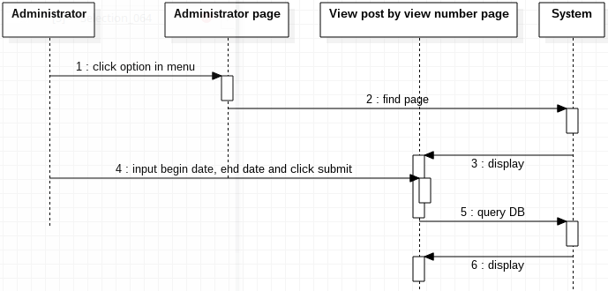

***8.3 Collaborator***

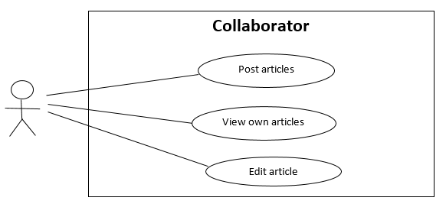

**8.3.1 Post article**

|  |  |  |
| --- | --- | --- |
| **Author** | Vo Gia Vu | |
| **Use Case Name** | Post articles | |
| **Actors** | Collaborator, Employee | |
| **Description** | Actor wants to post articles to system for pending | |
| **Requirements** | Actor provide articles information | |
| **Pre-conditions** | Actor has logged in as Collaborator | |
| **Post-conditions** | Success: Actor creates an article and sends to system in pending status  Fail:  - Page reload with message  - Refill information | |
| **Basic flow** | Actor Actions:  1. Actor click ‘Write new artibles’ button on menu  3. Actor input article’s information, select and ‘Subcategory’ combo box and click ‘Submit’ button. [Alternative 1] | System Responses:  2. System redirects to ‘upload.jsp’ page and display Article form with following control:  - ‘Title’ text area  - ‘Content’ text area  - ‘Subcategory’ combo box  - ‘Insert image’ buttom  - ‘Upload article’ button  4. System checks the information [Exception 1]  5. System create new article in DB  6. Display |
| **Alternative flow** | Actor Actions:  [Alternative 1]  1. Actor click ‘Home’ button | System Responses:  2. System returns to Home page. |
| **Exception** | Actor Actions:  [Exception 1]  1. Actor left ‘Title’ text field blank.  2. Title has already existed  3. Actor left ‘Content’ text area blank. | System Responses:  System display message to Actor:  - ‘Title cannot be blank.’  - ‘This Title has already existed’  - ‘Content cannot be blank.’ |

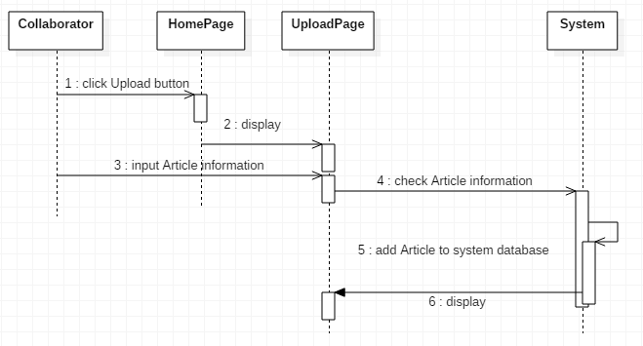

**8.3.2 View own article**

|  |  |  |
| --- | --- | --- |
| **Author** | Vo Gia Vu | |
| **Use Case Name** | View own articles | |
| **Actors** | Collaborator & Employee | |
| **Description** | Collaborator, employee wants to view their own article including pending, accepted, rejected articles | |
| **Requirements** |  | |
| **Pre-conditions** | Actor has logged in as Collaborator | |
| **Post-conditions** | Success: Chosen article shows up  Fail: Error Page shown | |
| **Basic flow** | Actor Actions:  1. Actor click ‘View my articles’ button on menu.  3. Actor click on the ‘Title’ hyperlink or ‘Theme image’ hyperlink of chosen article to view [Alternative 1] | System Responses:  2. System redirects to ‘manageArticle.jsp’ page and display article list in grid layout. Articles grouped by status and displayed in order latest to oldest with these information:  - ’Theme image’ hyperlink  - ’Title’ hyperlink  - ‘Date time’ label  4. System redirects to ‘articleDetail.jsp’ page and display article in a frame with information:  + On the right:  - sub-category  - Date time  - Title  - Content  - Author  - Views  - (Rejected reason only for the rejected article)  - (‘Edit’ button only for the accepted and the pending articles)  + Same sub-category articles on the left panel  + Below is the comments:  - every comment has a button ‘X’ for directly delete comment. |
| **Alternative flow** | Actor Actions:  [Alternative 1]  1. Actor click ‘Home’ button | System Responses:  2. System returns to Home page. |
| **Exceptio­n** |  |  |

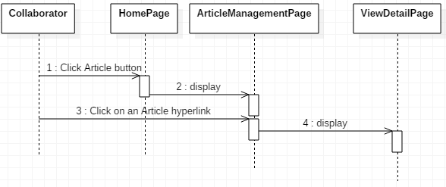

**8.3.3 Edit own articles**

|  |  |  |
| --- | --- | --- |
| **Author** | Vo Gia Vu | |
| **Use Case Name** | Edit own articles | |
| **Actors** | Collaborator, Employee | |
| **Description** | Actor wants to edit his own articles | |
| **Requirements** | Actor provide article information | |
| **Pre-conditions** | Actor has logged in | |
| **Post-conditions** | Success: Article is modified and updated into database  Fail: Refill information | |
| **Basic flow** | Actor Actions:  1. Actor click ‘Edit’ button on ‘articleDetail.jsp’ page whose article is the accepted or pending article.  3. Actor modify information and click ‘Submit’ button [Alternative 1] [Alternative 2] | System Responses:  2. System redirects to ‘editArticle.jsp’ page and display article in a frame with information:  - ‘Subcategory’ combo box  - ‘Title’ text box  - ‘Content’ text area  - ‘Submit’ button  - ‘Cancel’ button  4. System checks the information and redirects to ‘articleDetail.jsp’ page and display article  [Exception 1] |
| **Alternative flow** | Actor Actions:  [Alternative 1]  1. Actor click ‘Cancel’ button  [Alternative 2]  1. Actor click ‘Home’ button | System Responses:  2. System redirects ‘articleDetail.jsp’ page and display article  2. System returns to Home page. |
| **Exception** | Actor Actions:  [Exception 1]  1. Actor left ‘Title’ text field blank.  2. Title has already existed  3. Actor left ‘Content’ text area blank. | System Responses:  - ‘Title cannot be blank’  - ‘This Title has already existed’  - ‘Content cannot be blank’ |

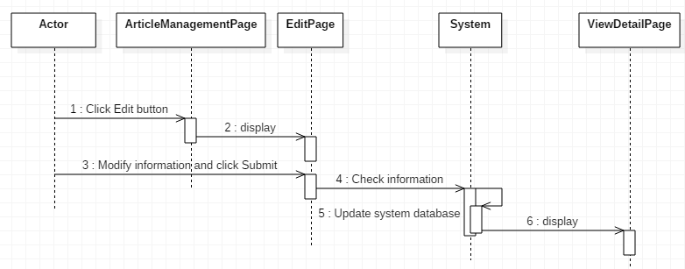

***8.4 Collaborator – Employee – Manager – Administrator***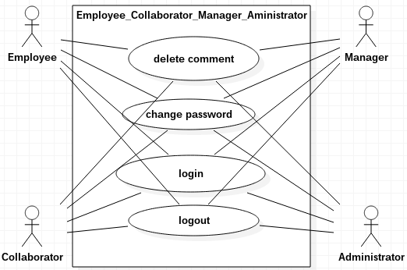

**8.4.1 Delete comment**

|  |  |  |
| --- | --- | --- |
| **Author** | Vo Gia Vu | |
| **Use Case Name** | Delete comment | |
| **Actors** | Collaborator or Employee or Manager or Administrator | |
| **Description** | Actor wants to delete comments on accepted article | |
| **Requirements** |  | |
| **Pre-conditions** | Actor has logged in | |
| **Post-conditions** | Success: Comment must be changed status in system database  Fail: Error Page shown | |
| **Basic flow** | Actor Actions:  1. Actor click ‘X’ button beside of comment which below article in ‘articleDetail.jsp’ page  3. Actor click ‘Yes’ button [Alternative1] | System Responses:  2. System display a confirm dialog with following control:  - Message ‘Delete this comment?’  - ‘Yes’ button  - ‘No’ button  4. System delete comments in DB.  5. System reload current page, ‘articleDetail.jsp’ |
| **Alternative flow** | Actor Actions:  [Alternative 1]  1. Actor click ‘No’ button | System Responses:  2. System close confirm dialog |
| **Exception** |  |  |

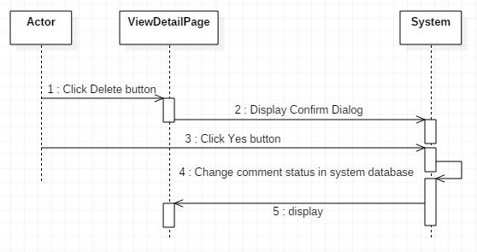

**8.4.2 Log in**

|  |  |  |
| --- | --- | --- |
| **Author** | Vo Gia Vu | |
| **Use Case Name** | Login | |
| **Actors** | Collaborator or Employee or Manager or Administrator | |
| **Description** | Actor wants to login | |
| **Requirements** | Actor provides username and password | |
| **Pre-conditions** |  | |
| **Post-conditions** | Success: User logged in to website  Fail:  - A message box displayed with message  - Refill information | |
| **Basic flow** | Actor Actions:  1. Actor type URL go to ‘login.jsp’ for login  3. Actor inputs ‘User Name’ and ‘Password’, then click the ‘Sign in’ button | System Responses:  2. System redirects to ‘login.jsp’ and displays Login form with following control:  - ‘User Name’ text field  - ‘Password’ text field  - ‘Sign in’ button  4. System checks the information [Exception 1]  5. System redirects to ‘home.jsp’ |
| **Alternative flow** | Actor Actions:  [Alternative 1]  1. Actor click ‘OK’ button to close message box, input ‘User Name’ and ‘Password’, then click ‘Login’ button | System Responses:  2. System checks the information [Exception 1] |
| **Exception** | Actor Actions:  [Exception 1]  1. Actor input invalid username and password | 2. System redirects to ‘login.jsp’ with following controls:  - ‘User Name’ text field  - ‘Password’ text field  - ‘Login’ button  - ‘Reset’ button  3. System show a message box: “Invalid Username or Password”. [Alternative 1] |

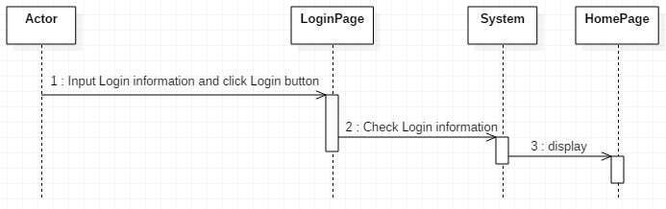

**8.4.3 Log out**

|  |  |  |
| --- | --- | --- |
| **Author** | Vo Gia Vu | |
| **Use Case Name** | Logout | |
| **Actors** | Collaborator or Employee or Manager or Administrator | |
| **Description** | Actor wants to log out of System | |
| **Requirements** |  | |
| **Pre-conditions** | Actor has logged in | |
| **Post-conditions** | Success: Actor logged out | |
| **Basic flow** | Actor Actions:  1. Actor click ‘Log out’ button on the menu  3. Actor click ‘Yes’ button [Alternative 1] | System Responses:  2. System shows confirm dialog with following control:  - Message ‘Want to log out?’  - ‘Yes’ button  - ‘No’ button  4. System removes session, then redirects to ‘Login’ page |
| **Alternative flow** | Actor Actions:  [Alternative 1]  1. Actor click ‘No’ button | System Responses:  2. System closes confirm dialog |
| **Exception** |  |  |

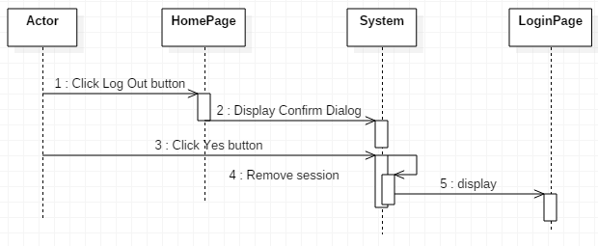

**8.4.4 Change password**

|  |  |  |
| --- | --- | --- |
| **Author** | Tran Trong Hieu | |
| **Use Case Name** | Change password | |
| **Actors** | Collaborator or Employee or Manager or Administrator | |
| **Description** | Actor wants to change their own password | |
| **Requirements** | Input old password, new password | |
| **Pre-conditions** | Actor has logged in | |
| **Post-conditions** | Success: DB update password of this actor  Fail:  - Form reload will message  - Refill form | |
| **Basic flow** | Actor Actions:  1. Actor click ‘Edit password’ button on the menu  3. Actor inputs value and click ‘Change’ button. [Alternative 1] | System Responses:  2. System shows confirm dialog with following control:  - ‘Old password’: text field  - ‘New password’: text field  - ‘Confirm password’: text field  - ‘Change’ button  - ‘Cancel’ button  4. System checks value in input fields.  [Exception 1]  5. System change password in server.  6. System announces successful. |
| **Alternative flow** | Actor actions:  [Alternative 1]  1. Actor clicks ‘Cancel’ button | System Responses:  2. System close dialog. |
| **Exception** | Actor Actions:  [Exception 1]  1. Actor leaves password blank.  2. Confirm password blank  3. Confirm password wrong | System Responses:  System reload dialog to Actor:  - ‘Password required’.  - ‘Confirm password is blank’.  - ‘Confirm not match’. |

**8.4.5 View own informations**

|  |  |  |
| --- | --- | --- |
| **Author** | Tran Trong Hieu | |
| **Use Case Name** | View own information | |
| **Actors** | Collaborator or Employee or Manager or Administrator | |
| **Description** | Actor wants to view their own informatrion | |
| **Requirements** |  | |
| **Pre-conditions** | Actor has logged in | |
| **Post-conditions** |  | |
| **Basic flow** | Actor Actions:  1. Actor clicks button ‘View information’ on menu | System Responses:  2. System redirects to ‘staffInfo.jsp’ have:  - Full name  - Username  - Phone number  - Email  - Date of birth  - Address  - Gender  - Working categories  - Role  3. System query DB to take information of this actor  4. System return result and display in ‘staffInfo.jsp’ |
| **Alternative flow** |  |  |
| **Exception** |  |  |

***8.5 Employee***

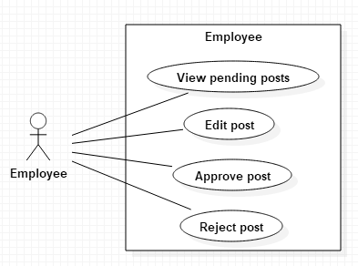

**8.5.1 View pending posts**

|  |  |  |
| --- | --- | --- |
| **Author** | Nguyen Viet Hung | |
| **Use Case Name** | View pending posts | |
| **Actors** | Employee, Manager | |
| **Description** | Actor can view pending posts of collaborator in the specific subcategories he/she manages. | |
| **Requirements** | System provide page with grid of pending posts by collaborator with Title, author’s name, time and first image. | |
| **Pre-conditions** | Actor must log in as Employee or Manager. | |
| **Post-conditions** | Success: Display a new page with the details of the post. | |
| **Basic flow** | Actor Actions:  1. Actor clicks ‘Browse Articles’ in the Menu bar.  3. Actor clicks on one of the post in grid. [Alternative 1] | System Responses:  2. System redirects to ‘manageArticleByState.jsp’ have a grid of pending posts, each item in grid present an article:  - Title.  - Subcategory  - Author’s name.  - Date created.  - First image in the post.  4. System redirects to ‘articleDetail.jsp’ page and display article in a frame with information:  + On the right:  - sub-category  - Date time  - Title  - Content  - Author  - Views  - ‘Approve’ button  - ‘Edit’ button  - ‘Reject’ button  + Same sub-category articles on the left panel  + Below is the comments:  - every comment has a button ‘X’ for directly delete comment. |
| **Alternative flow** | Actor Actions:  [Alternative 1]  1. Actor click ‘Home’ button | System Responses:  2. System returns to ‘home.jsp’ page. |
| **Exception** |  |  |

**8.5.2 Edit posts**

|  |  |  |
| --- | --- | --- |
| **Author** | Nguyen Viet Hung | |
| **Use Case Name** | Edit posts | |
| **Actors** | Employee, Manager | |
| **Description** | Actor can edit pending post of collaborator before approving it. | |
| **Requirements** | System provide Details Post page with details of pending post with Title, subcategory, author’s name, time and content. | |
| **Pre-conditions** | Actor must log in as Employee or Manager. | |
| **Post-conditions** | Success: Edit post and approve it.  Fail: Show Error Page. | |
| **Basic flow** | Actor Actions:  1. Actor clicks ‘Edit’ button in the article.  3. Actor edits title, subcategory and content if necessary and click ‘Approve’ button. [Alternative 1] [Alternative 2] | System Responses:  2. System redirects to ‘editArticle.jsp’ page:  - Title: text field.  - Subcategory: combo box.  - Content: text area.  - ‘Approve’ button.  - ‘Cancel’ button.  4. System checks value in input fields.  [Exception 1]  5. System updates post in server:  - Title  - Subcategory  - Content  - Status: ‘pending for manager’ (employee’s action) or ‘rejected’ (manager’s action)  - ReviewID  - ApproverID  - LastModifiedDateTime  - lastEditorID  6. System announces successful and redirect to ‘manageArticleByState.jsp’ page. |
| **Alternative flow** | Actor Actions:  [Alternative 1]  1. Actor clicks ‘Cancel’ button  [Alternative 2]  3. Actor clicks ‘Home’ button | System Responses:  2. System returns to 'articleDetail.jsp’ page.  4. System returns to ‘home.jsp’ |
| **Exception** | Actor Actions:  [Exception 1]  1. Actor deletes all text in ‘title’ text field.  2. Actor deletes all content in ‘content’ area. | System Responses:  System displays message to Actor:  - ‘Title cannot be blank’.  - ‘Content cannot be blank’. |

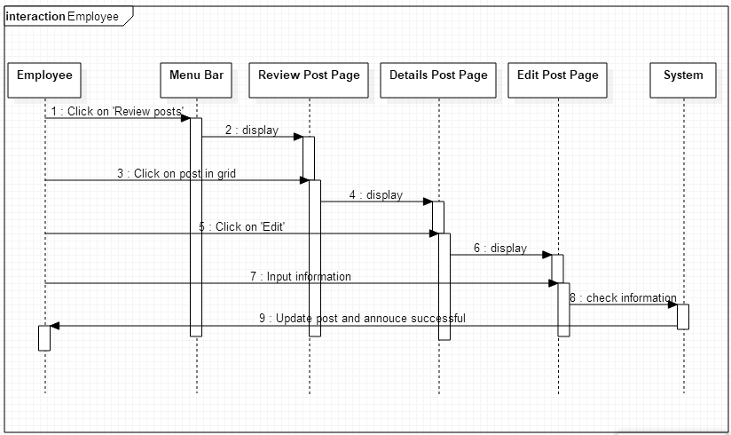

**8.5.3 Approve posts**

|  |  |  |
| --- | --- | --- |
| **Author** | Nguyen Viet Hung | |
| **Use Case Name** | Approve posts | |
| **Actors** | Employee, Manager | |
| **Description** | Actor can approve post. With employee, after approving, the post will be passed to manager, with manager, approved post will be showed on the website. | |
| **Requirements** | System provide Details Post page with details of pending post with Title, subcategory, author’s name, time and content. | |
| **Pre-conditions** | Actor must log in as Employee or Manager. | |
| **Post-conditions** | Success: Approve post.  Fail: Show Error Page. | |
| **Basic flow** | Actor Actions:  1. Actor clicks ‘Approve’ button in the ‘articleDetail.jsp’.  [Alternative 1] | System Responses:  2. System updates post in server:  - Status: ‘pending for manager’ (employee’s action) or ‘accepted’ (manager’s action)  3. System announces successful and redirect to ‘manageArticleByState.jsp’ page. |
| **Alternative flow** | Actor Actions:  [Alternative 1]  1. Actor clicks ‘Home’ button | System Responses:  2. System returns to ‘home.jsp’ |
| **Exception** |  |  |

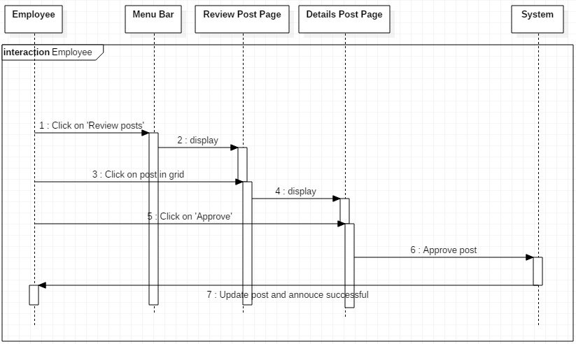

**8.5.4 Reject posts**

|  |  |  |
| --- | --- | --- |
| **Author** | Nguyen Viet Hung | |
| **Use Case Name** | Reject posts | |
| **Actors** | Employee, Manager | |
| **Description** | Actor can reject post. A reason for rejecting the post will be required. | |
| **Requirements** | - Actor input reject reason | |
| **Pre-conditions** | Actor must log in as Employee or Manager. | |
| **Post-conditions** | Success: Reject post.  Fail: Show Error Page. | |
| **Basic flow** | Actor Actions:  1. Actor clicks ‘Reject’ button in the ‘articleDetail.jsp’.  [Alternative 1]  3. Actor inputs the reason and clicks ‘Reject’ button in the modal.  [Alternative 2] | System Responses:  2. System displays a dialog to ask the reason for rejecting the post:  - ‘Reason’ text area  - ‘Reject’ button  - ‘Cancel’ button  4. System checks value in input fields.  [Exception 1]  5. System updates post in server:  - Status: ‘rejected’  - ReviewerID  - ApproverID  - LastModifiedDateTime  - LastEditorID  6. System announces successful and redirect to ‘manageArticleByState.jsp’ |
| **Alternative flow** | Actor Actions:  [Alternative 1]  1. Actor clicks ‘Home’ button  [Alternative 2]  1. Actor clicks ‘Cancel’ button | System Responses:  2. System returns to ‘home.jsp’  2. System closes the modal. |
| **Exception** | Actor Actions:  [Exception 1]  1. Actor leaves ‘Reason’ blank. | System Responses:  System displays message in dialog;  - ‘Reason is required’. |

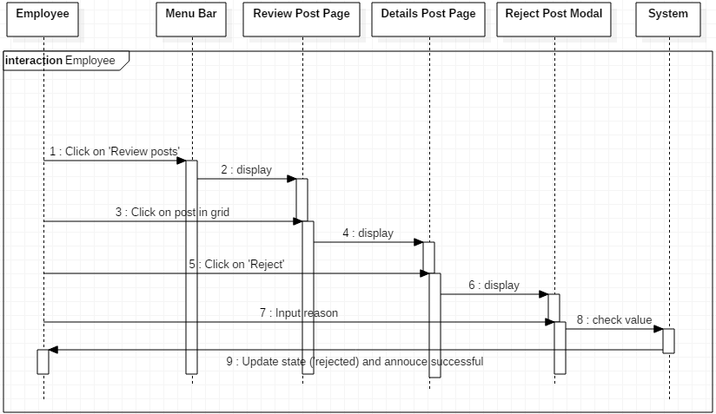

***8.6 Manager***

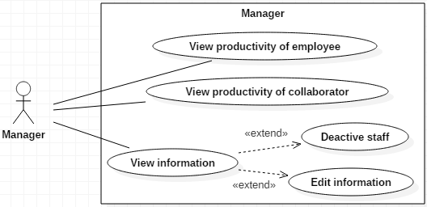

**8.6.1 View productivity of collaborator**

|  |  |  |
| --- | --- | --- |
| **Author** | Nguyen Viet Hung | |
| **Use Case Name** | View productivity of collaborator | |
| **Actors** | Manager, Administrator | |
| **Description** | Actor can view the productivity of all collaborators. | |
| **Requirements** |  | |
| **Pre-conditions** | Actor must log in as Manager or Administrator. | |
| **Post-conditions** | Success: Display a new page with the grid of collaborators. | |
| **Basic flow** | Actor Actions:  1. Actor clicks ‘View collaborators’ in menu. | System Responses:  2. System redirects to ‘manageCollaborator.jsp’ page have:  + ‘Create new staff’ button  +a grid of collaborators with:  - Name – hyperlink to ‘editStaff.jsp’  - User name.  - Total of accepted posts  - Total of rejected posts  - Total of pending posts  - Average time for every new post  - Average views and comments |
| **Alternative flow** |  |  |
| **Exception** |  |  |

**8.6.2 View productivity of employee**

|  |  |  |
| --- | --- | --- |
| **Author** | Nguyen Viet Hung | |
| **Use Case Name** | View productivity of employee | |
| **Actors** | Manager, Administrator | |
| **Description** | Actor can view the productivity of all employees. | |
| **Requirements** |  | |
| **Pre-conditions** | Actor must log in as Manager or Administrator. | |
| **Post-conditions** | Success: Display a new page with the grid of employees. | |
| **Basic flow** | Actor Actions:  1. Actor clicks ‘View employees’ in menu | System Responses:  2. System redirects to ‘manageEmployee.jsp’ have:  + ‘Create new staff’ button  + a grid of collaborators with:  - Name – hyperlink to ‘editStaff.jsp’  - Username  - Total of posts accepted by employee.  - Total of posts rejected by employee.  - Average time for checking new posts.  - Average views and comments of posted approved by employee. |
| **Alternative flow** |  |  |
| **Exception** |  |  |

**8.6.3 View information and deactivate staff**

|  |  |  |
| --- | --- | --- |
| **Author** | Nguyen Viet Hung | |
| **Use Case Name** | View information and deactivate staff | |
| **Actors** | Manager, Administrator | |
| **Description** | Actor can view information of all employees and collaborators then deactivate them. | |
| **Requirements** |  | |
| **Pre-conditions** | Actor must log in as Manager or Administrator. | |
| **Post-conditions** | Success: Deactivate staff.  Fail: Show Error Page. | |
| **Basic flow** | Actor Actions:  1. Actor clicks on name of staff on the grid of ‘manageEmployee.jsp’ OR ‘manageCollaborator.jsp’  [Alternative 1]  3. Actor clicks on ‘Deactivate’ button.  [Alternative 1]  5. Actor clicks on ‘OK’ button.  [Alternative 2] | System Responses:  2. System redirects to ‘editStaff.jsp’ have these components:  - Full name: text field  - Phone number: text field  - Email: text field  - Date of birth: text field  - Address: text field  - Gender: radio button  - Working categories: check box  - Role: combo box  - ’Edit’ button  - ‘Deactivate’ button  - ‘Cancel’ button  4. System shows a confirm modal with ‘OK’ button and ‘Cancel’ button.  6. System updates that staff as deactivated and show successful message. |
| **Alternative flow** | Actor actions:  [Alternative 1]  1. Actor clicks ‘Home’ button  [Alternative 2]  3. Actor clicks ‘Cancel’ button | System Responses:  2. System returns to ‘home.jsp’  4. System closes modal. |
| **Exception** |  |  |

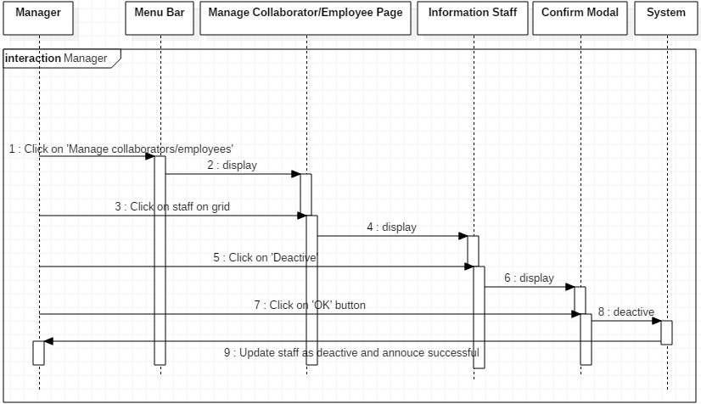

**8.6.4 Edit staff information**

|  |  |  |
| --- | --- | --- |
| **Author** | Nguyen Viet Hung | |
| **Use Case Name** | Edit staff information | |
| **Actors** | Manager, Administrator | |
| **Description** | Actor can edit information of staffs. | |
| **Requirements** |  | |
| **Pre-conditions** | Actor must log in as Manager or Administrator. | |
| **Post-conditions** | Success: Edit staff information.  Fail: Show Error Page. | |
| **Basic flow** | Actor Actions:  1. Actor clicks on ‘Name’ – hyperlink in an entry on ‘manageCollaborator.jsp’ OR ‘manageEmployee.jsp’  [Alternative 1]  3. Actor inputs value and click ‘Edit’ button. [Alternative 1] | System Responses:  2. System redirects to ‘editStaff.jsp’ have these components:  - Full name: text field  - Phone number: text field  - Email: text field  - Date of birth: text field  - Address: text field  - Gender: radio button  - Working categories: check box  - Role: combo box  - ’Edit’ button  - ‘Deactivate’ button  - ‘Cancel’ button  (All fields are required)  4. System checks value in input fields.  [Exception 1]  5. System updates staff in server.  6. System announces successful |
| **Alternative flow** | Actor actions:  [Alternative 1]  1. Actor clicks ‘Home’ button | System Responses:  2. System returns to ‘home.jsp’ |
| **Exception** | Actor Actions:  [Exception 1]  1. Actor ‘Full name’ blank.  7. Actor ‘Phone number’ blank.  8. Actor leaves ‘Email’ blank.  9. Actor leaves ‘Date of Birth’ blank.  10. Actor leaves ‘Address’ blank.  11. Actor doesn’t choose gender.  12. Actor doesn’t choose working categories. | System Responses:  System displays message to Actor:  - ‘Full name required’  - ‘Phone number required’  - ‘Email required’.  - ‘Date of birth required’  - ‘Address required’  - ‘Gender required’.  - ‘Working categories required’. |

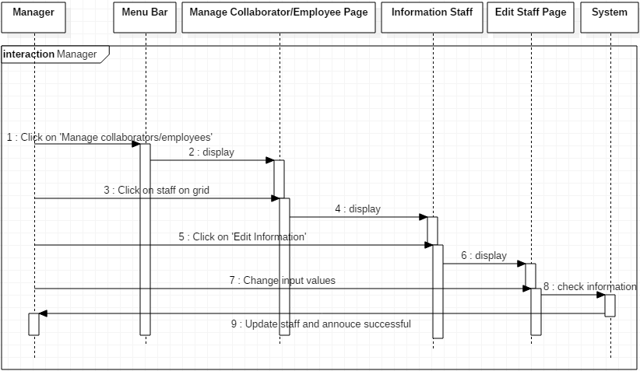

**8.6.5 Create new staff**

|  |  |  |
| --- | --- | --- |
| **Author** | Nguyen Viet Hung | |
| **Use Case Name** | Create new staff | |
| **Actors** | Manager, Administrator | |
| **Description** | Actor can create new staff. | |
| **Requirements** |  | |
| **Pre-conditions** | Actor must log in as Manager or Administrator. | |
| **Post-conditions** | Success: Create new staff.  Fail: Show Error Page. | |
| **Basic flow** | Actor Actions:  1. Actor clicks on ‘Create new staff’ button on ‘manageEmployee.jsp’ OR ‘manageCollaborator.jsp’  [Alternative 1]  3. Actor inputs value and click ‘Create staff’ button. [Alternative 1] [Alternative 2] | System Responses:  2. System redirects to ‘createStaff.jsp’ page:  - Full name: text field  - Phone number: text field  - Email: text field  - Date of birth: text field  - Address: text field  - Gender: radio button  - Working categories: check box  - Role: combo box  (All fields are required)  - ‘Create staff’ button  - ‘Cancel’ button  4. System checks value in input fields.  [Exception 1]  5. System inserts new staff in server.  6. System announces successful. |
| **Alternative flow** | Actor actions:  [Alternative 1]  1. Actor clicks ‘Home’ button  [Alternative 2]  3. Actor clicks ‘Cancel’ button | System Responses:  2. System returns to ‘home.jsp’  4. System returns to ‘manageEmployee.jsp’ or ‘manageCollaborator.jsp’ |
| **Exception** | Actor Actions:  [Exception 1]  1. Actor leaves ‘Full name’ blank.  3. Actor leaves ‘Username’ blank.  4. Username is existed.  7. Actor leaves ‘Phone number’ blank.  8. Actor leaves email blank.  9. Actor leaves ‘Date of birth’ blank.  10. ‘Date of birth’ wrong format  10. Actor leaves ‘Address’ blank.  11. Actor doesn’t choose gender.  12. Actor doesn’t choose working categories. | System Responses:  System displays message to Actor:  - ‘Full name required’  - ‘Username required’.  - ‘Username existed’.  - ‘Phone number required’.  - ‘Email required’.  - ‘Date of birth required’  - ‘Date format is: YYYY-MM-DD’  - ‘Address required’  - ‘Gender required’  - ‘Working categories required’ |

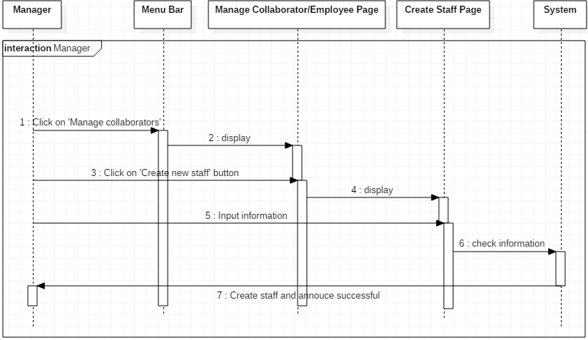

# 9. Entity Relationship Diagram (ERD)

***9.1 Conceptual***

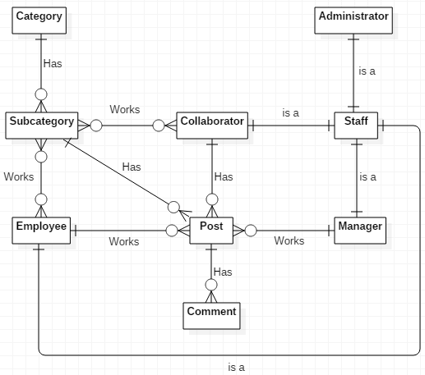

***9.2 Table***

**9.2.1 Staff**

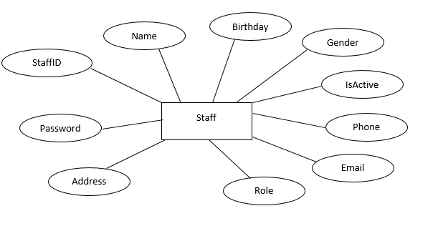

**9.2.2 Article**

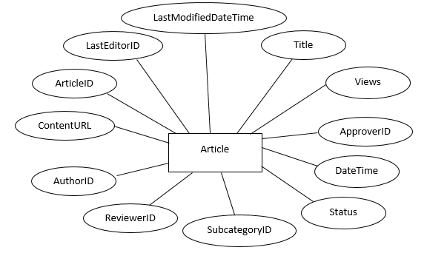

**9.2.3 Comment**

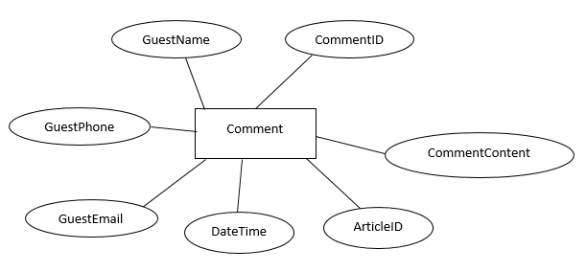

**9.2.4 Category**

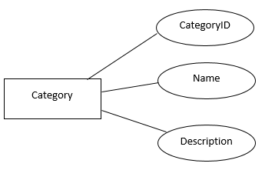

**9.2.5 Subcategory**

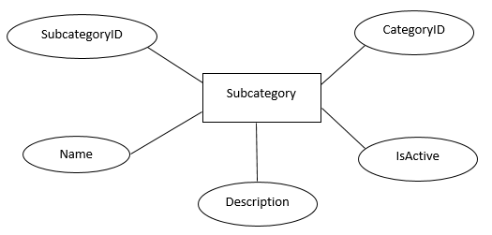

**9.2.5 WorkingSubcategory**

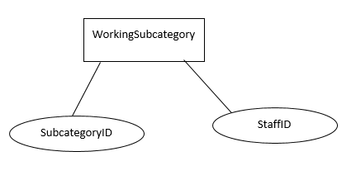

**REVIEW 3**

# 10. Database Relationship Diagram

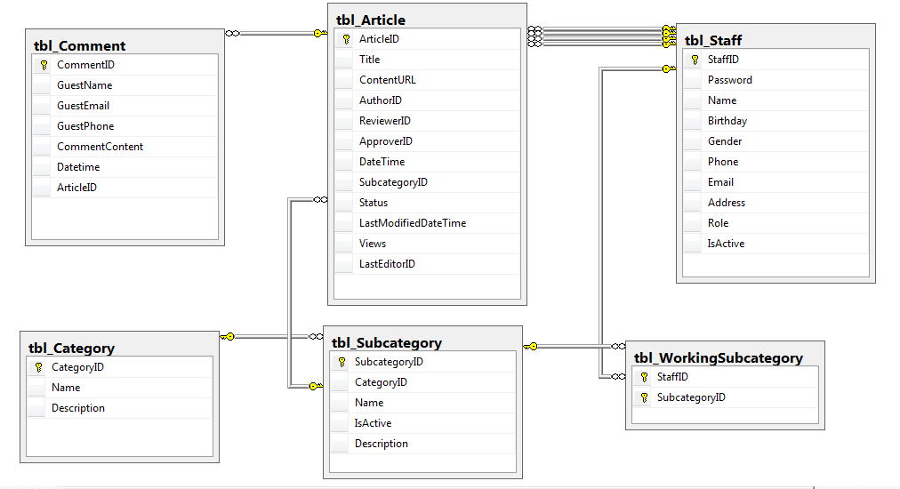

**11. Table Definition**

***11.1 Category***

|  |  |  |  |  |  |  |  |
| --- | --- | --- | --- | --- | --- | --- | --- |
| **Key** | **Field Name** | **Data Type** | **Length** | **Allow Null** | **Default value** | **Table-Field-Ref** | **Description** |
| PK | **CategoryID** | nvarchar | 10 | No |  |  | Category ID |
|  | Name | nvarchar | 50 | No |  |  | Name |
|  | Description | nvarchar | 250 | Yes |  |  | Category description |

Constraint:

|  |  |  |  |
| --- | --- | --- | --- |
| **Name** | **Add** | **Delete** | **Update** |
| Category | - | - | + |

11.2 SubCategory

|  |  |  |  |  |  |  |  |
| --- | --- | --- | --- | --- | --- | --- | --- |
| **Key** | **Field Name** | **Data Type** | **Length** | **Allow Null** | **Default value** | **Table-Field-Ref** | **Description** |
| PK | **SubcategoryID** | nvarchar | 10 | No |  |  | Subcategory ID |
|  | CategoryID | nvarchar | 10 | No |  | Category.CategoryID | Category ID, FK of Category table |
|  | Name | nvarchar | 50 | No |  |  | Name |
|  | IsActive | bit | 1 | No | 0 |  | Status of Category  0: Active  1: Inactive |
|  | Description | nvarchar | 250 | Yes |  |  | Subcategory description |

**Constraints:**

|  |  |  |  |
| --- | --- | --- | --- |
| **Name** | **Add** | **Delete** | **Update** |
| Subcategory | + | +  (no Article references to this Subcategory) | + |

|  |  |  |  |  |  |  |  |
| --- | --- | --- | --- | --- | --- | --- | --- |
| **Key** | **Field Name** | **Data Type** | **Length** | **Allow Null** | **Default value** | **Table-Field-Ref** | **Description** |
| PK | **ArticleID** | nvarchar | 10 | No |  |  | Article ID |
| FK | SubcategoryID | nvarchar | 10 | No |  | Subcategory.SubcategoryID | Subcategory ID, FK of Subcategory table |
|  | Title | nvarchar | 100 | No |  |  | Title of article |
|  | ContentLink | nvarchar | 200 | No |  |  | Link to the content of article |
| FK | AuthorID | nvarchar | 20 | No |  | Staff.StaffID | ID of Author, FK of Staff table |
| FK | ReviewerID | nvarchar | 20 | Yes |  | Staff.StaffID | ID of Reviewer, FK of Staff table |
| FK | ApproverID | nvarchar | 20 | Yes |  | Staff.StaffID | ID of Approver, FK of Staff table |
| FK | LastEditorID | nvarchar | 20 | Yes |  |  | ID of the last staff modified article,FK of Staff table |
|  | DateTime | datetime | 8 | No |  |  | Date and time of latest status changed |
|  | LastModifiedDateTime | datetime | 8 | Yes |  |  | Last date and time article modified |
|  | Status | nvarchar | 15 | No |  |  | Status of article  -‘Rejected’  -‘Pending for Employee’  -‘Pending for Manager’  -‘Accepted’ |
|  | Views | int | 4 | No |  |  | Number of view of article |

**11.3 Article**

**Constraint:**

|  |  |  |  |
| --- | --- | --- | --- |
| **Name** | **Add** | **Delete** | **Update** |
| Article | + | - | + |

**11.4 Comment**

|  |  |  |  |  |  |  |  |
| --- | --- | --- | --- | --- | --- | --- | --- |
| **Key** | **Field Name** | **Data Type** | **Length** | **Allow Null** | **Default value** | **Table-Field-Ref** | **Description** |
| PK | **CommentID** | nvarchar | 10 | No |  |  | Comment ID |
| FK | ArticleID | nvarchar | 10 | No |  | Article.ArticleID | Article ID, FK of Article table |
|  | GuestName | nvarchar | 50 | No |  |  | Guest name |
|  | GuestPhone | nvarchar | 12 | Yes |  |  | Guest phone number |
|  | GuestEmail | nvarchar | 30 | Yes |  |  | Guest email |
|  | CommentContent | nvarchar | 500 | No |  |  | Content of guest comment |
|  | DateTime | datetime | 8 | No |  |  | Date and time posting comment |

**Constraint:**

|  |  |  |  |  |  |
| --- | --- | --- | --- | --- | --- |
| **Name** | | | **Add** | **Delete** | **Update** |
| Comment | + | + | - | | |

**11.5 Staff**

|  |  |  |  |  |  |  |  |
| --- | --- | --- | --- | --- | --- | --- | --- |
| **Key** | **Field Name** | **Data Type** | **Length** | **Allow Null** | **Default value** | **Table-Field-Ref** | **Description** |
| PK | **StaffID** | nvarchar | 20 | No |  |  | Staff ID |
|  | Password | nvarchar | 20 | No |  |  | Password |
|  | Name | nvarchar | 50 | No |  |  | Staff name |
|  | Phone | nvarchar | 12 | No |  |  | Staff phone number |
|  | Email | nvarchar | 30 | No |  |  | Staff email |
|  | Birthday | date | 8 | No |  |  | Staff date of birth |
|  | Gender | nvarchar | 13 | No |  |  | Staff gender |
|  | Address | nvarchar | 200 | No |  |  | Staff address |
|  | Role | nvarchar | 13 | No |  |  | Staff role:  -‘Administrator’  -‘Manager’  -‘Employee’  -‘Collaborator’ |
|  | IsActive | bit | 1 | No | 0 |  | Status of comment:  0: Active  1: Inactive |

**Constraint:**

|  |  |  |  |
| --- | --- | --- | --- |
| **Name** | **Add** | **Delete** | **Update** |
| Staff | +  (Cannot add a staff as role Administrator) | - | + |

|  |  |  |  |  |  |  |  |
| --- | --- | --- | --- | --- | --- | --- | --- |
| **Key** | **Field Name** | **Data Type** | **Length** | **Allow Null** | **Default value** | **Table-Field-Ref** | **Description** |
| FK | **StaffID** | nvarchar | 20 | No |  | Staff.StaffID | Staff ID, FK of Staff table |
| FK | **SubcategoryID** | nvarchar | 10 | No |  | Subcategory.SubcategoryID | Subcategory ID, FK of Subcategory table |

**11.6 WorkingSubcategory**

**Constraint:**

|  |  |  |  |
| --- | --- | --- | --- |
| **Name** | **Add** | **Delete** | **Update** |
| WorkingSubcategory | + | + | + |

**12. Other constraints:**

**12.1 Category and Subcategory**

|  |  |  |  |
| --- | --- | --- | --- |
| **Name** | **Add** | **Delete** | **Update** |
| Category | - | - | +  (Category.CategoryID cannot be changed) |
| Subcategory | +  (Category.CategoryID must exist) | + | +  (Subcategory.SubcategoryID cannot be changed) |

**12.2 Subcategory and Article**

|  |  |  |  |
| --- | --- | --- | --- |
| **Name** | **Add** | **Delete** | **Update** |
| Subcategory | + | +  (Subcategory.SubcategoryID is not exist in Article) | +  (Subcategory.SubcategoryID cannot be changed) |
| Article | +  (Subcategory.SubcategoryID must exist) | - | +  (Article.ArticleID cannot be changed) |

**12.3 Article and Comment**

|  |  |  |  |
| --- | --- | --- | --- |
| **Name** | **Add** | **Delete** | **Update** |
| Article | + | - | +  (Article.ArticleID cannot be changed) |
| Comment | +  (Article.ArticleID must exist) | + | - |

**12.4 Staff and Article**

|  |  |  |  |
| --- | --- | --- | --- |
| **Name** | **Add** | **Delete** | **Update** |
| Staff | + | - | +  (Staff.StaffID cannot be changed) |
| Article | +  (Staff.StaffID must exist) | - | +  (Article.ArticleID cannot be changed) |

**12.5 Subcategory and WorkingSubcategory**

|  |  |  |  |
| --- | --- | --- | --- |
| **Name** | **Add** | **Delete** | **Update** |
| Subcategory | + | -  (Subcategory.SubcategoryID is not existed in WorkingSubcategory) | +  (Subcategory. SubcategoryID cannot be changed) |
| WorkingSubcategory | +  (Subcategory.SubcategoryID must exist) | + | +  (Subcategory.SubcategoryID must exist) |

**12.6 Staff and WorkingSubCategory**

|  |  |  |  |
| --- | --- | --- | --- |
| **Name** | **Add** | **Delete** | **Update** |
| Staff | + | - | +  (Staff.StaffID cannot be changed) |
| WorkingSubcategory | +  (Staff.StaffID must exist) | + | +  (Staff.StaffID must exist) |

**13. Site Map**

***13.1 Guest side***

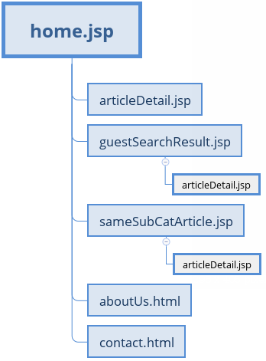

***13.2 Collaborator side***

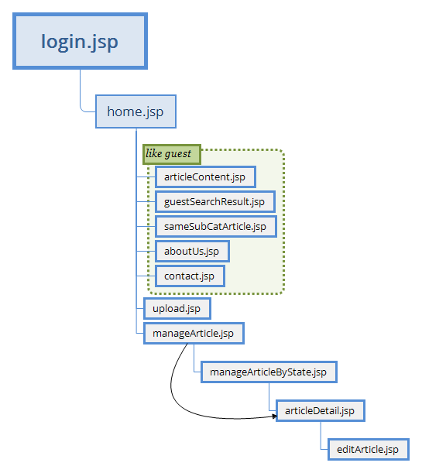

***13.3 Employee side***

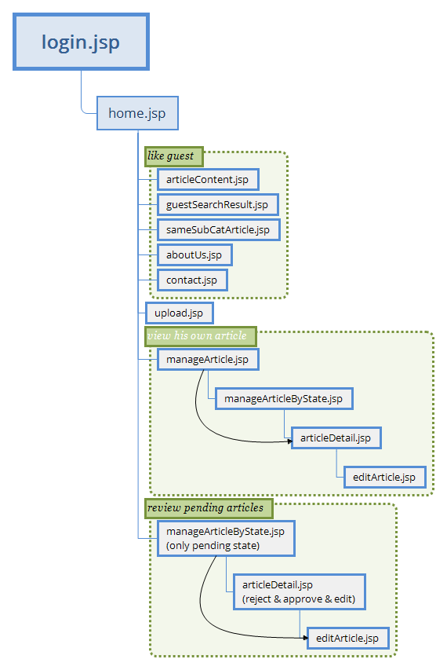

***13.4 Manager side***

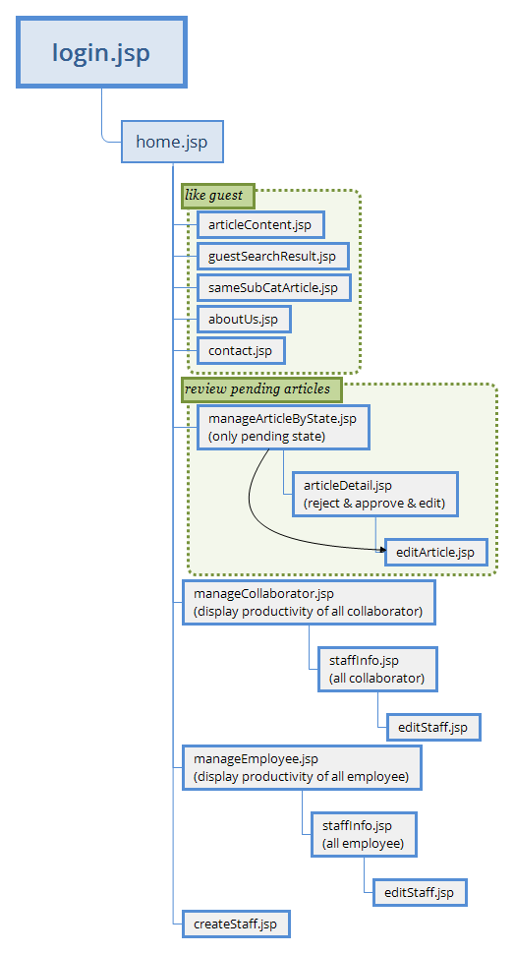

***13.5 Administrator side***

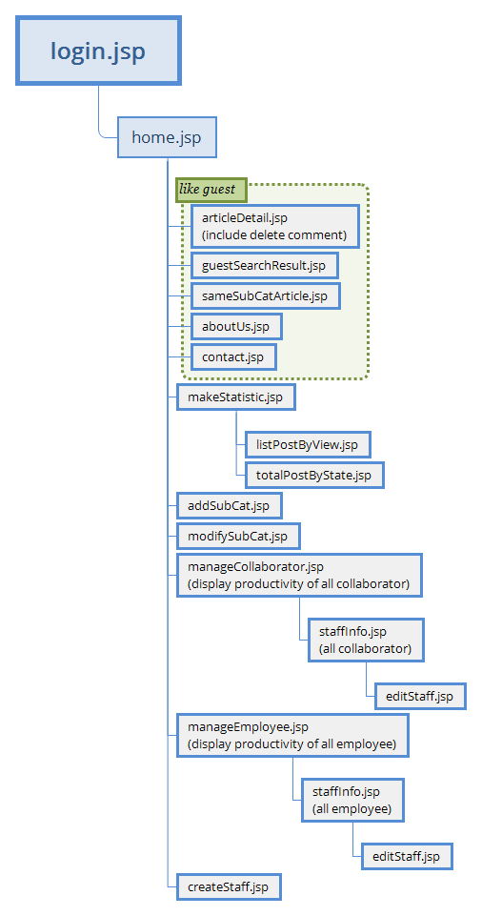

**14. Gui Design**

***14.1 home.jsp (guest)***

9

8

7

6

4

3

2

1

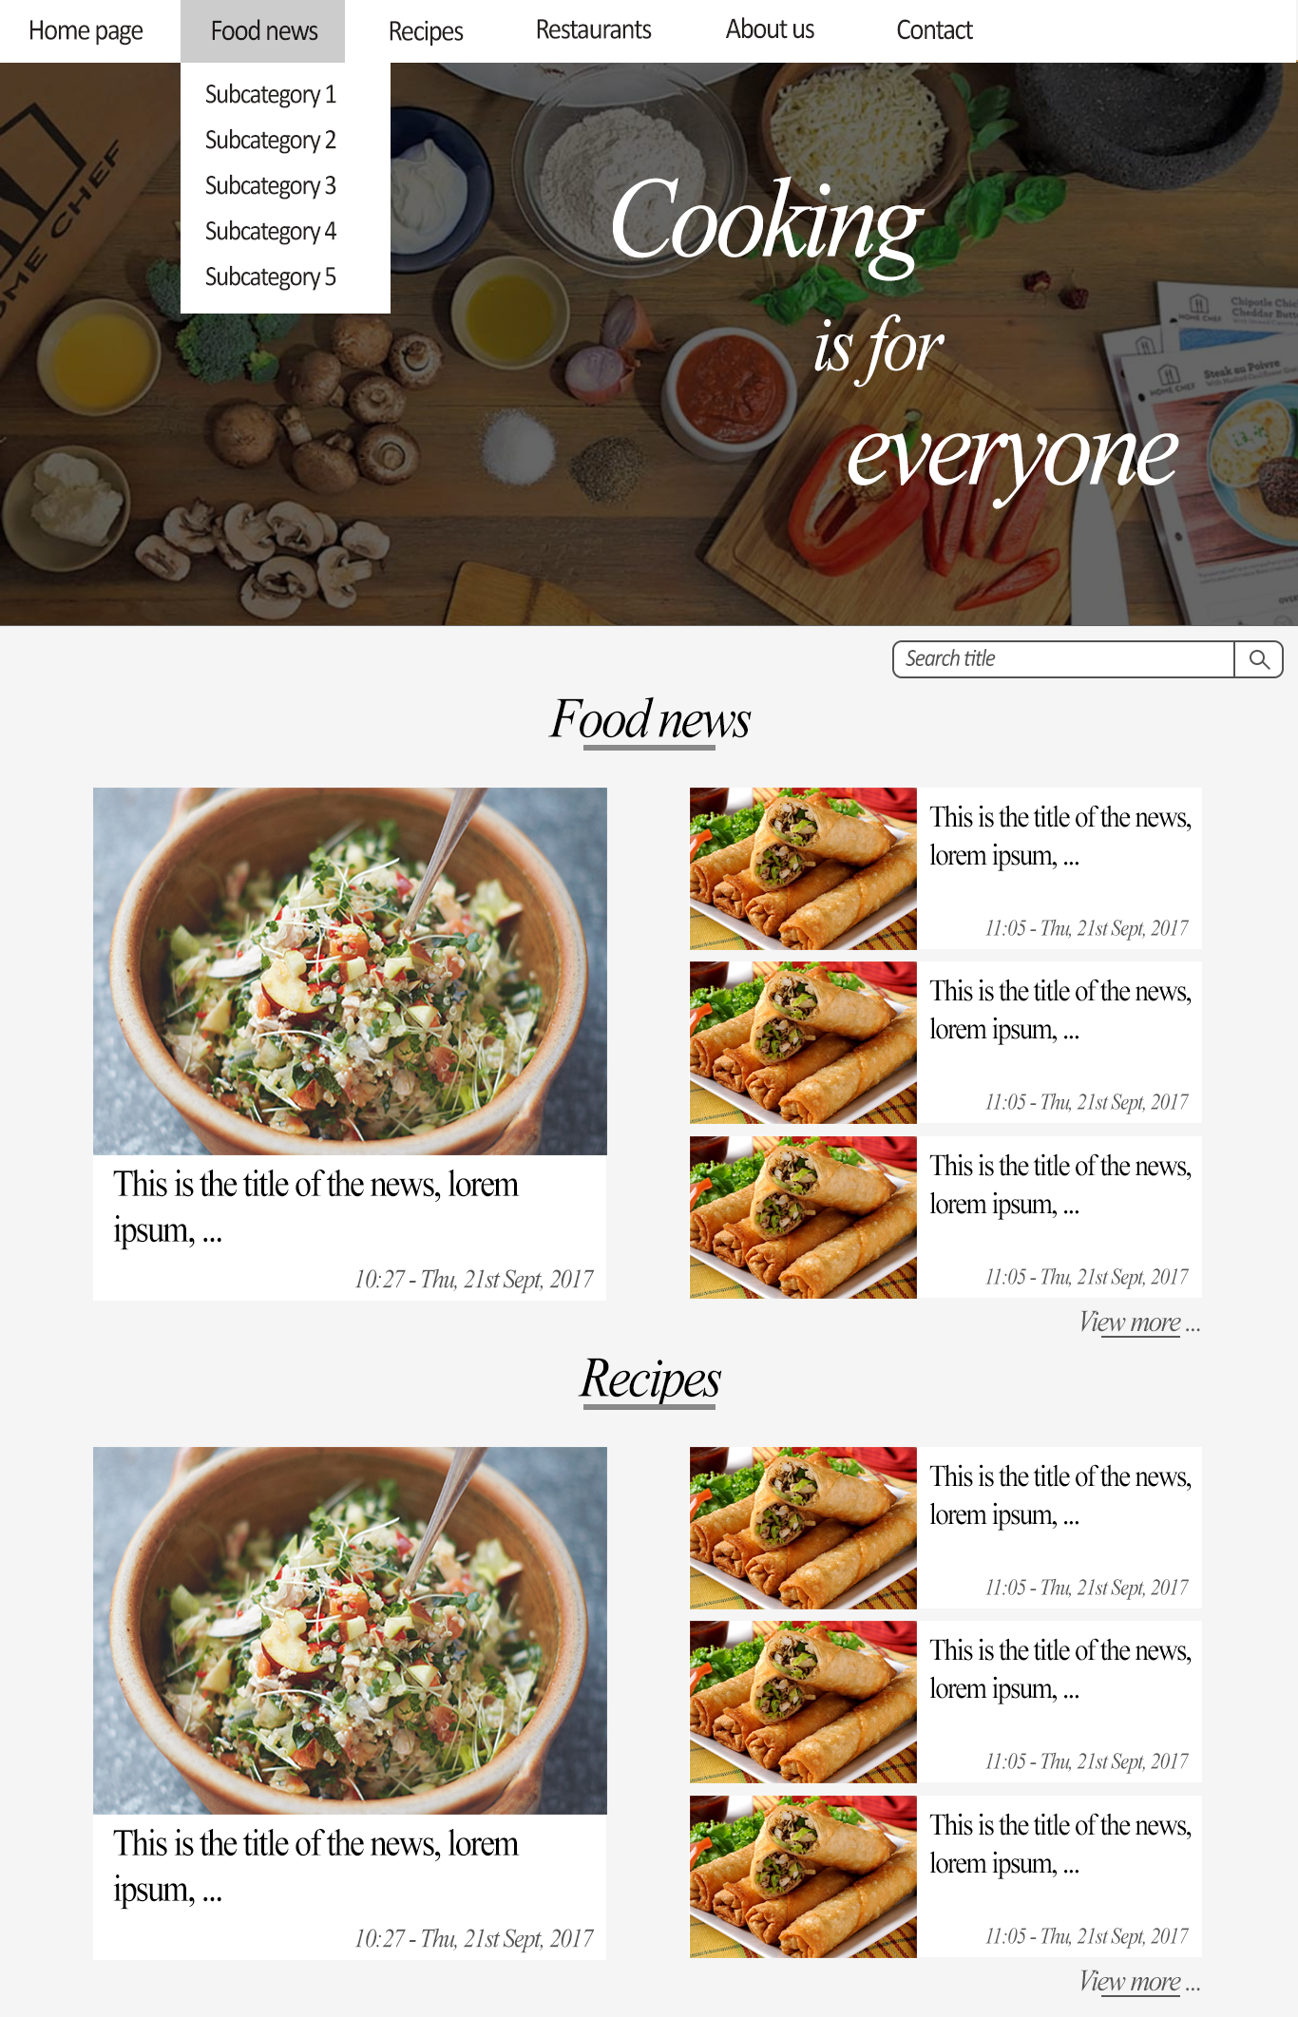

11

13

14

15

16

12

5

|  |  |  |  |  |  |  |
| --- | --- | --- | --- | --- | --- | --- |
| **No.** | **Name** | **Type** | **Validation** | **Event** | **Description** | **Status** |
| 1 | btnHome | Button |  | Click | Redirect to Home page |  |
| 2 | lstNews | List |  | Over | - List of Subcategories data get from Subcategory table |  |
| 3 | lstRecipes | List |  | Over | - List of Subcategories data get from Subcategory table |  |
| 4 | lstRestaurants | List |  | Over | - List of Subcategories data get from Subcategory table |  |
| 5 | btnSubcategories | Hyperlink |  | Click | Redirect to Subcategory page |  |
| 6 | btnAboutUs | Button |  | Click | Redirect to AboutUs page |  |
| 7 | btnContact | Button |  | Click | Redirect to Contact page |  |
| 8 | txtSearch | Text field |  |  | Search value |  |
| 9 | btnSearch | Button |  | Click | Redirect to Search page |  |
| 10 | gridListOfCategories | Grid |  |  | Grid list of categories contains controls:12,13,14 |  |
| 11 | lblCategory | Label |  |  | Category name |  |
| 12 | gridListOfArticles | Grid |  |  | Grid list of articles data get from Article table contains controls: 15,16,17 |  |
| 13 | btnViewMore | Hyperlink |  | Click | Redirect to Subcategory page |  |
| 14 | imgArticle | Image |  | Click | Redirect to Details page |  |
| 15 | lblTitle | Label |  | Click | Redirect to Details page |  |
| 16 | lblDateTime | Label |  |  | Article created date time |  |

***14.2 sameSubCatArticle.jsp***

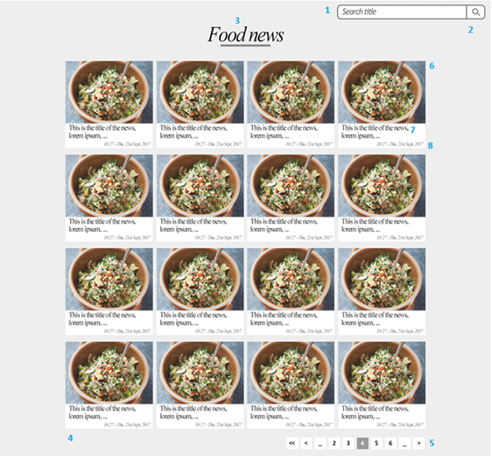

|  |  |  |  |  |  |  |
| --- | --- | --- | --- | --- | --- | --- |
| **No.** | **Name** | **Type** | **Validation** | **Event** | **Description** | **Status** |
| 1 | txtSearchValue | Text field |  |  | Part of article’s title want to search |  |
| 2 | btnSearch | Button |  | Click | Query DB for artible by title and redirect to ‘guestSearchResult.jsp’ |  |
| 3 | lblChosenSubCat | Label |  |  | Name of chosen Subcategory |  |
| 4 | gridSearchResults | Grid |  |  | Grid contains controls:  - 6, 7, 8 |  |
| 5 | Paging | Paging |  | Click | Go to page |  |
| 6 | imgLink | Image, Hyperlink |  | Click | Link go to ‘articleDetail.jsp’ to see detail of article |  |
| 7 | lblTitle | Hyperlink |  | Click | Link go to ‘articleDetail.jsp’ to see detail of article |  |
| 8 | lblDateUp | Label |  |  | Date when this article is created. |  |

***14.3 guestSearchResult.jsp***

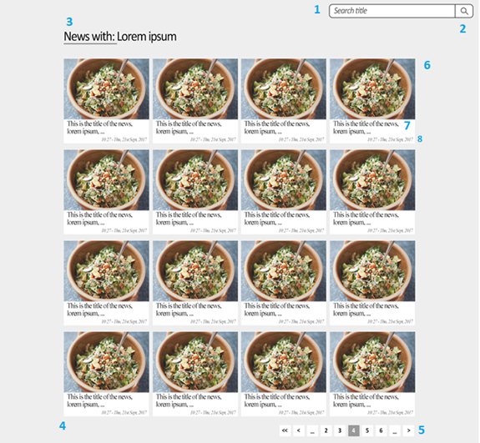

|  |  |  |  |  |  |  |
| --- | --- | --- | --- | --- | --- | --- |
| **No.** | **Name** | **Type** | **Validation** | **Event** | **Description** | **Status** |
| 1 | txtSearchValue | Text field |  |  | Part of article’s title want to search |  |
| 2 | btnSearch | Button |  | Click | Query DB for artible by title and redirect to ‘guestSearchResult.jsp’ |  |
| 3 | lblSearchValue | Label |  |  | Search string guest input |  |
| 4 | gridSearchResults | Grid |  |  | Grid contains controls:  - 6, 7, 8 |  |
| 5 | Paging | Paging |  | Click | Go to page |  |
| 6 | imgLink | Image, Hyperlink |  | Click | Link go to ‘articleDetail.jsp’ to see detail of article |  |
| 7 | lblTitle | Hyperlink |  | Click | Link go to ‘articleDetail.jsp’ to see detail of article |  |
| 8 | lblDateUp | Label |  |  | Date when this article is created. |  |

***14.4 aboutUs.html***

***14.5 contact.html***

***14.6 articleDetail.jsp (Guest)***

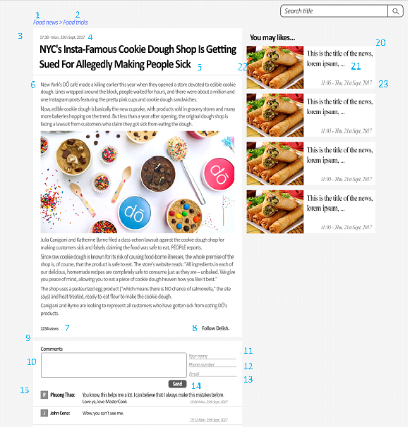

|  |  |  |  |  |  |  |
| --- | --- | --- | --- | --- | --- | --- |
| **No.** | **Name** | **Type** | **Validation** | **Event** | **Description** | **Status** |
| 1 | lblCategory | Label |  |  | Category name |  |
| 2 | btnSubcategory | Hyperlink |  | Click | Redirect to Subcategory page |  |
| 3 | gridDetail | Grid |  |  | Grid contains controls: 4,5,6,7,8 data get from Article table |  |
| 4 | lblDateTime | Label |  |  | Article created date time |  |
| 5 | lblTitle | Label |  |  | Article title |  |
| 6 | txtContent | Div |  |  | Article content |  |
| 7 | lblView | Label |  |  | Article views |  |
| 8 | lblAuthor | Label |  |  | Article’s author name |  |
| 9 | gridComment | Grid |  |  | Grid contains controls: 10,11,12,13,14,15 |  |
| 10 | txtComment | Text area | 0 < length <=500 |  | Comment content |  |
| 11 | txtName | Text field | Not null  0 < length < 50 |  | Guest name |  |
| 12 | txtPhone | Text field | 0 <= length < 12 |  | Guest phone |  |
| 13 | txtEmail | Text field | 0 <= length < 30  /.+@.+\.[a-z]+/ |  | Guest email |  |
| 14 | btnSend | Button |  | Click | Send guest comment to system and update gridComment |  |
| 15 | gridListOfComments | Grid |  |  | List of comments data get from Comment table contains controls: 16,17,18,19 |  |
| 16 | txtCap | Div |  |  | First letter of guest name |  |
| 17 | lblName | Label |  |  | Guest name |  |
| 18 | lblContent | Label |  |  | Comment content |  |
| 19 | lblCommentDate | Label |  |  | Comment date time |  |
| 20 | gridListOfOtherArticles | Grid |  |  | Grid of other articles data get from Article table contains controls: 21,22,23 |  |
| 21 | btnTitle | Hyperlink |  | Click | Redirect to Detail page |  |
| 22 | imgArticle | Image |  | Click | Redirect to Detail page |  |
| 23 | lblOtherArticleDate | Label |  |  | Article created date time |  |

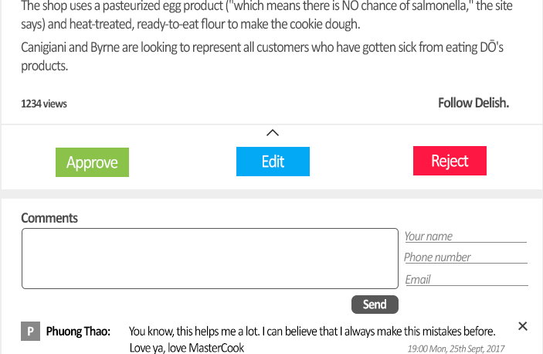

24

25

26

27

28

|  |  |  |  |  |  |  |
| --- | --- | --- | --- | --- | --- | --- |
| **No.** | **Name** | **Type** | **Validation** | **Event** | **Description** | **Status** |
| 24 | gridControls | Grid |  |  | Grid contains controls: 25,26,27,28 | Invisible with Guest |
| 25 | btnApprove | Button |  | Click | Change article status and redirect to ManageArticle page | Invisible with role lower or equal to its owner or “Rejected” or “Accepted” article |
| 26 | btnEdit | Button |  | Click | Redirect to Edit page | Invisible with Guest or ”Rejected” article |
| 27 | btnReject | Button |  | Click | Appear a modal to input reject reason | Invisible with role lower or equal to its owner or “Rejected” article |
| 28 | btnRemoveCmt | Button |  | Click | Delete this comment | Invisible with guest |

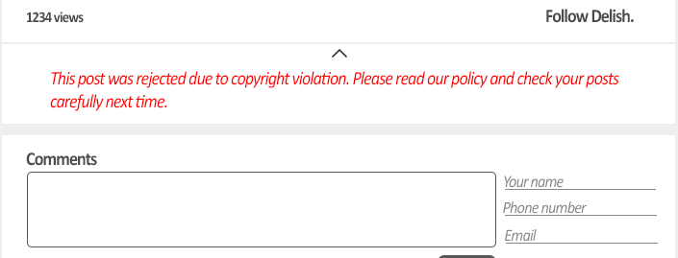

29

|  |  |  |  |  |  |  |
| --- | --- | --- | --- | --- | --- | --- |
| **No.** | **Name** | **Type** | **Validation** | **Event** | **Description** | **Status** |
| 29 | lblReason | Label |  |  | Rejected reason | Invisible with Guest and not “Rejected” article |

***14.7 login.jsp***

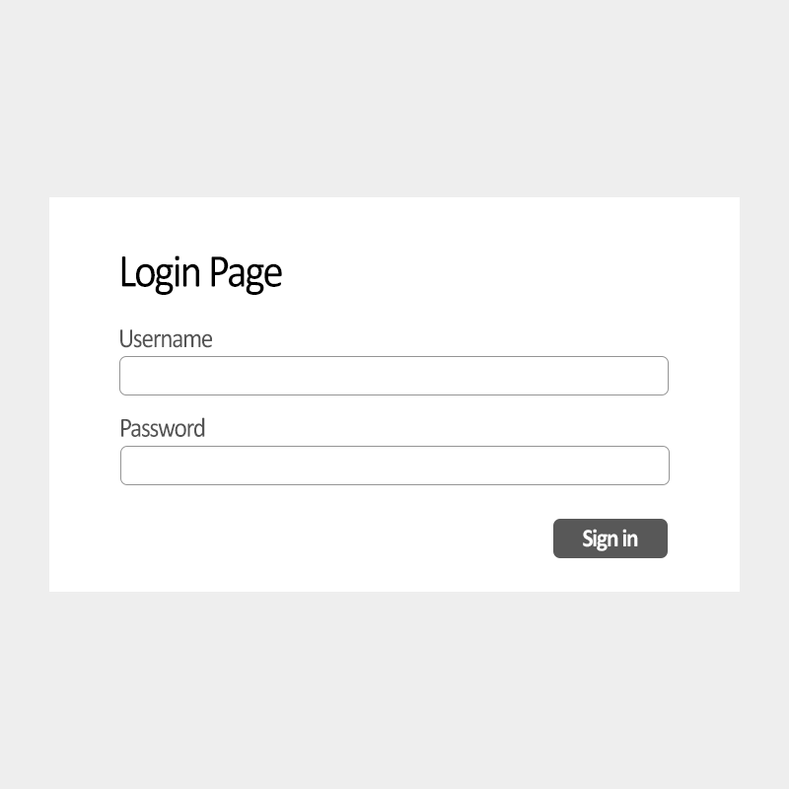

1

2

3

|  |  |  |  |  |  |  |
| --- | --- | --- | --- | --- | --- | --- |
| **No.** | **Name** | **Type** | **Validation** | **Event** | **Description** | **Status** |
| 1 | txtUsername | Text field | Not null |  | User name |  |
| 2 | txtPassword | Text field | Not null |  | Password |  |
| 3 | btnSignIn | Button |  | Click | Login to the system and redirect to Home page |  |

***14.8 home.jsp (Ad)***

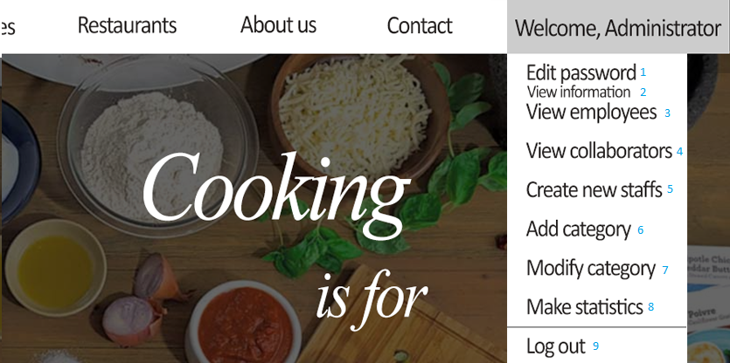

|  |  |  |  |  |  |  |
| --- | --- | --- | --- | --- | --- | --- |
| **No.** | **Name** | **Type** | **Validation** | **Event** | **Description** | **Status** |
| 1 | btnEditPassword | Hyperlink |  | Click | Show a dialog for change his own password |  |
| 2 | btnViewOwnInfo | Hyperlink |  | Click | Redirect to ‘ownInfo.jsp’ |  |
| 3 | btnViewEmployee | Hyperlink |  | Click | Redirect to ‘manageEmployee.jsp’ |  |
| 4 | btnViewCollabotator | Hyperlink |  | Click | Redirect to ‘manageCollaborator.jsp’ |  |
| 5 | btnCreateStaff | Hyperlink |  | Click | Redirect to ‘createStaff.jsp’ |  |
| 6 | btnAddSubCat | Hyperlink |  | Click | Redirect to ‘addSubCat.jsp’ |  |
| 7 | btnModifySubCat | Hyperlink |  | Click | Redirect to ‘modifySubCat.jsp’ |  |
| 8 | btnMakeStatistic | Hyperlink |  | Click | Redirect to ‘makeStatistict.jsp’ |  |
| 9 | btnLogout | Button |  | Click | Logout current account. Redirect to ‘home.jsp’ for guest |  |

***14.9 home.jsp (Man)***

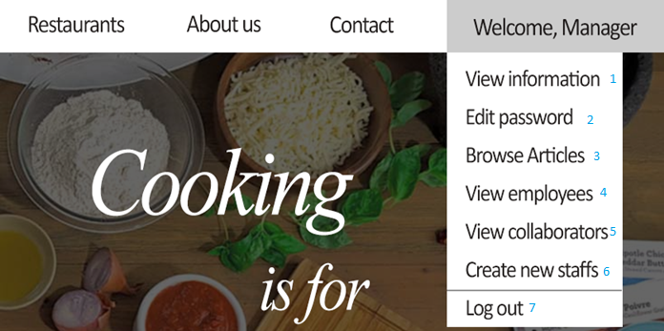

|  |  |  |  |  |  |  |
| --- | --- | --- | --- | --- | --- | --- |
| **No.** | **Name** | **Type** | **Validation** | **Event** | **Description** | **Status** |
| 1 | btnEditPassword | Hyperlink |  | Click | Show a dialog for change his own password |  |
| 2 | btnViewEmployee | Hyperlink |  | Click | Redirect to ‘manageEmployee.jsp’ |  |
| 3 | btnViewCollabotator | Hyperlink |  | Click | Redirect to ‘manageCollaborator.jsp’ |  |
| 4 | btnCreateStaff | Hyperlink |  | Click | Redirect to ‘createStaff.jsp’ |  |
| 5 | btnUpdateCat | Hyperlink |  | Click | Redirect to ‘modifySubCat.jsp’ |  |
| 6 | btnMakeStatistic | Hyperlink |  | Click | Redirect to ‘makeStatistict.jsp’ |  |
| 7 | btnLogout | Button |  | Click | Logout current account. Redirect to ‘home.jsp’ for guest |  |

***14.10 home.jsp (Col)***

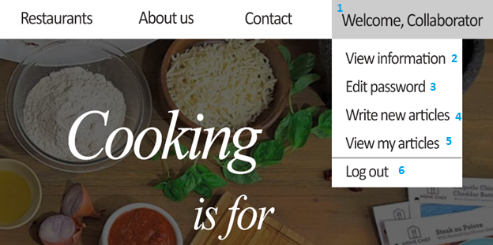

|  |  |  |  |  |  |  |
| --- | --- | --- | --- | --- | --- | --- |
| **No.** | **Name** | **Type** | **Validation** | **Event** | **Description** | **Status** |
| 1 | lbWelcome | Label |  | Hover | List Collaborator functions |  |
| 2 | btnViewInfo | Hyperlink |  | Click | Redirect to ViewInfo page |  |
| 3 | btnEditPass | Hyperlink |  | Click | Redirect to EditPass page |  |
| 4 | btnWriteArticle | Hyperlink |  | Click | Redirect to WriteArticle page |  |
| 5 | btnViewArticle | Hyperlink |  | Click | Redirect to Detail page |  |
| 6 | btnLogOut | Button |  | Click | Logout current account. Redirect to Home page |  |

***14.11 home.jsp (Emp)***

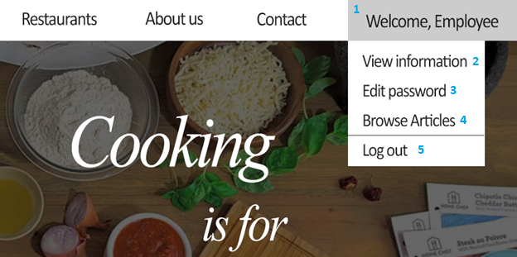

|  |  |  |  |  |  |  |
| --- | --- | --- | --- | --- | --- | --- |
| **No.** | **Name** | **Type** | **Validation** | **Event** | **Description** | **Status** |
| 1 | lbWelcome | Label |  | Hover | List Employee functions |  |
| 2 | btnViewInfo | Hyperlink |  | Click | Redirect to ViewInfo page |  |
| 3 | btnEditPass | Hyperlink |  | Click | Redirect to EditPass page |  |
| 4 | btnBrowse | Hyperlink |  | Click | Redirect to ‘manageArticle.jsp’ |  |
| 5 | btnLogOut | Button |  | Click | Logout current account. Redirect to Home page |  |

***14.12 Change password***

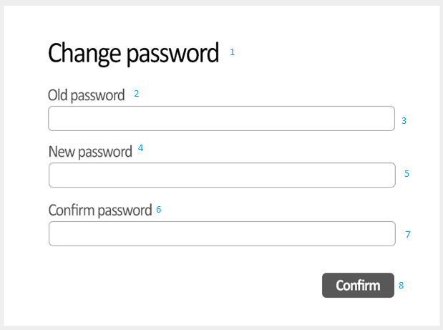

|  |  |  |  |  |  |  |
| --- | --- | --- | --- | --- | --- | --- |
| **No.** | **Name** | **Type** | **Validation** | **Event** | **Description** | **Status** |
| 1 | lbChangePassword | Label |  |  | Label ‘Change password’ |  |
| 2 | lbOldPassword | Label |  |  | Label ‘New password’ |  |
| 3 | txtOldPassword | Text field | not null |  | Input current password |  |
| 4 | lbNewPassword | Label |  |  | Label ‘Old password’ |  |
| 5 | txtNewPassword | Text field | not null |  | Input new password |  |
| 6 | lbConfirmPassword | Label |  |  | Label ‘Confirm password’ |  |
| 7 | txtConfirmPassword | Text field | not null |  | Confirm password |  |
| 8 | btnChangePassword | Button |  | Click | Submit the form to change password |  |

***14.13 upload.jsp (Emp, Col)***



1

2

3

4

5

|  |  |  |  |  |  |  |
| --- | --- | --- | --- | --- | --- | --- |
| **No.** | **Name** | **Type** | **Validation** | **Event** | **Description** | **Status** |
| 1 | txtContent | Div |  |  | Article content data get from Article table | Editable |
| 2 | txtTitle | Text field |  |  | Article title data get from Article table |  |
| 3 | cbSubcategory | Combobox |  |  | Subcategory data get from Subcategory table |  |
| 4 | btnInsertImage | File field |  | Click | Browser picture to insert |  |
| 5 | btnUpload | Button |  | Click | Upload article to system for pending |  |

***14.14 manageArticle.jsp (Emp, Col)***

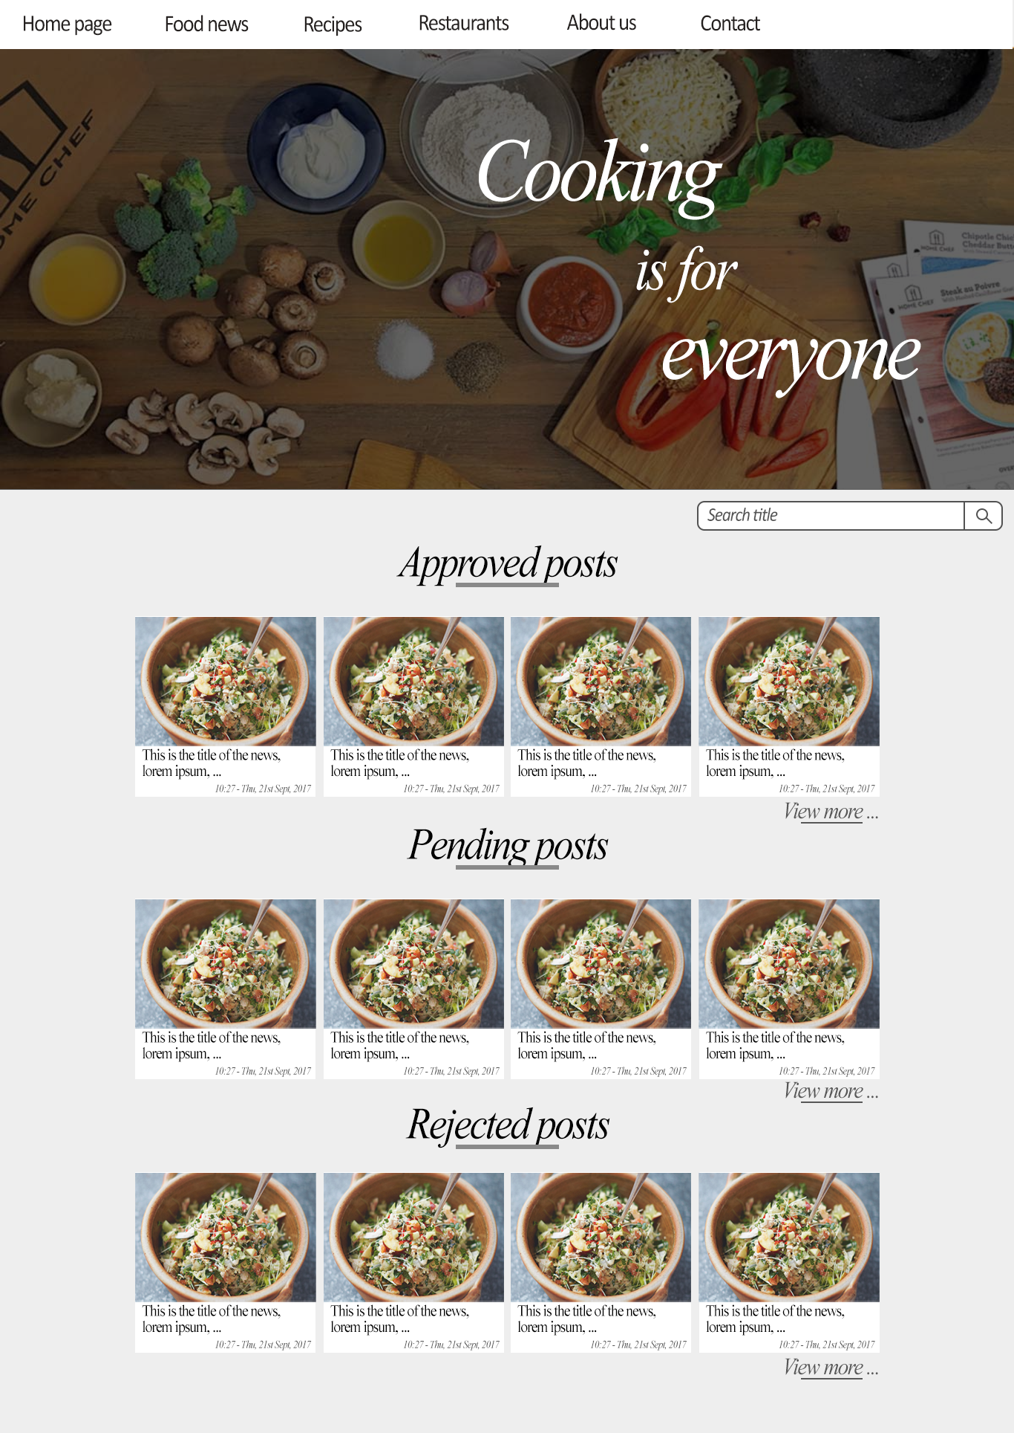

1

2

3

4

5

6

7

8

9

|  |  |  |  |  |  |  |
| --- | --- | --- | --- | --- | --- | --- |
| **No.** | **Name** | **Type** | **Validation** | **Event** | **Description** | **Status** |
| 1 | lbApproved | Label |  |  | Approved status |  |
| 2 | gridListOfApprovedArticles | Grid |  |  | Grid list of approved articles with article’s information data get from Article table |  |
| 3 | btnViewMore | Hyperlink |  | Click | Redirect to ApprovedPosts page |  |
| 4 | lbPending | Label |  |  | Pending status |  |
| 5 | gridListOfPendingArticles | Grid |  |  | Grid list of pending articles with article’s information data get from Article table |  |
| 6 | btnViewMore | Hyperlink |  | Click | Redirect to PendingPosts page |  |
| 7 | lbRejected | Label |  |  | Rejected status |  |
| 8 | gridListOfRejectedArticles | Grid |  |  | Grid list of rejected articles with article’s information data get from Article table |  |
| 9 | btnViewMore | Hyperlink |  | Click | Redirect to RejectedPosts page |  |

***14.15 manageCollaborator.jsp (Ad, Man)***

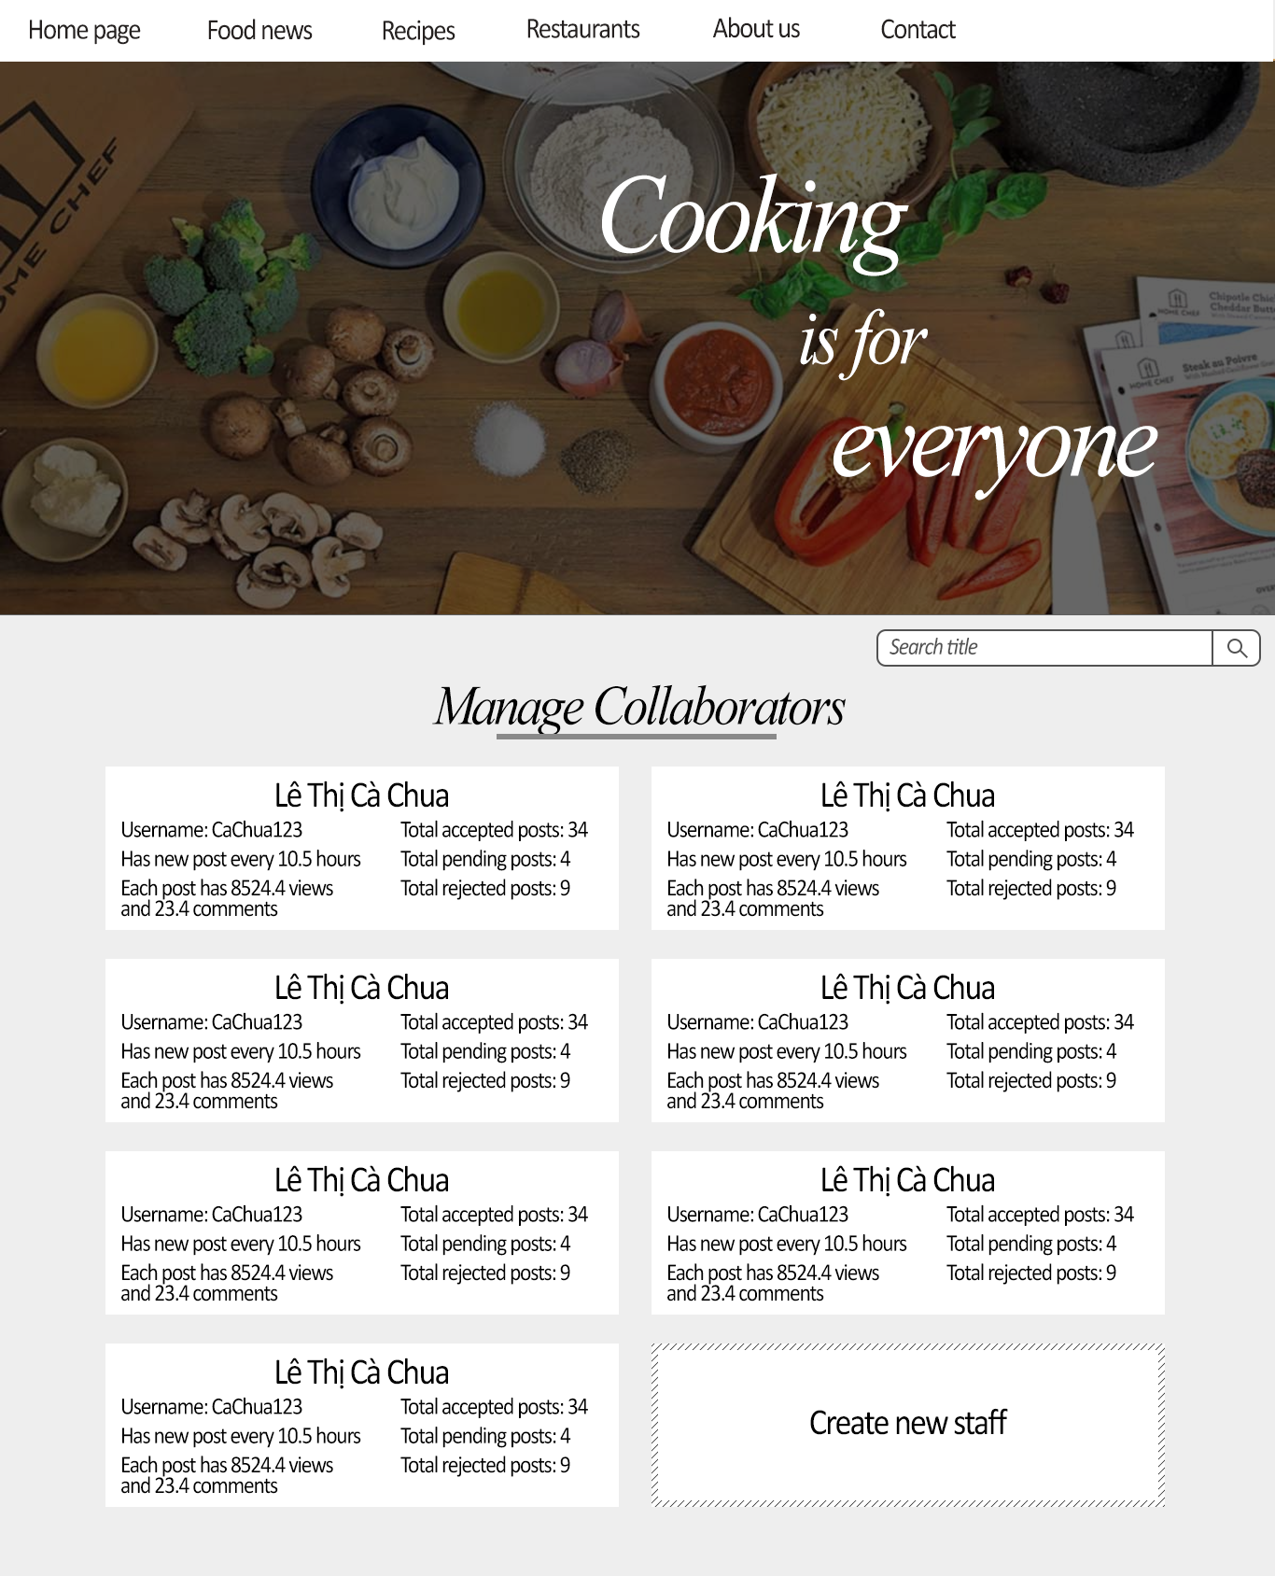

1

8

9

10

2

4

5

6

7

3

11

|  |  |  |  |  |  |  |
| --- | --- | --- | --- | --- | --- | --- |
| **No.** | **Name** | **Type** | **Validation** | **Event** | **Description** | **Status** |
| 1 | lbCollaborator | Label |  |  | Label Collaborator |  |
| 2 | gridListOfCollaboratorPanels | Grid |  |  | Grid list of panel contains information of Collaborator data get from Staff table and from query |  |
| 3 | panelCollaborator | Panel |  |  | Panel contains Collaborator information |  |
| 4 | lnkName | Hyperlink |  | Click | Collaborator name |  |
| 5 | lbUsername | Label |  |  | Collaborator ID |  |
| 6 | lbNewPost | Label |  |  | Average interval time Collaborator upload a new post |  |
| 7 | lbViewAndComment | Label |  |  | Average views and comments of accepted Articles |  |
| 8 | lbAccepted | Label |  |  | Number of accepted articles |  |
| 9 | lbPending | Label |  |  | Number of pending articles |  |
| 10 | lbRejected | Label |  |  | Number of rejected articles |  |
| 11 | btnCreate | Button |  | Click | Redirect to CreateStaff page |  |

***14.16 manageEmployee.jsp (Ad, Man)***

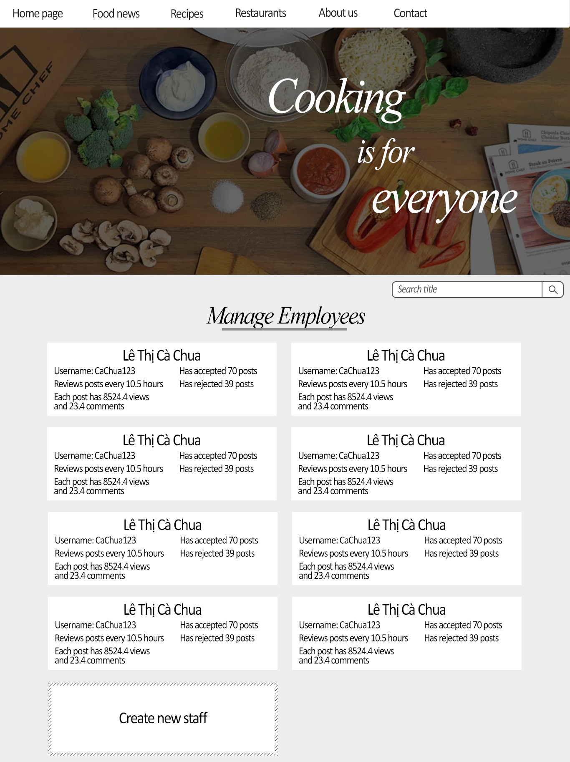

4

5

6

7

1

8

9

2

3

10

|  |  |  |  |  |  |  |
| --- | --- | --- | --- | --- | --- | --- |
| **No.** | **Name** | **Type** | **Validation** | **Event** | **Description** | **Status** |
| 1 | lbEmployee | Label |  |  | Label Employee |  |
| 2 | gridListOfEmployeePanels | Grid |  |  | Grid list of panel contains information of Employee data get from Staff table and from query |  |
| 3 | panelEmployee | Panel |  |  | Panel contains Employee information |  |
| 4 | lnkName | Hyperlink |  | Click | Employee name |  |
| 5 | lbUsername | Label |  |  | Employee ID |  |
| 6 | lbReview | Label |  |  | Average interval time Employee review posts |  |
| 7 | lbViewAndComment | Label |  |  | Average views and comments of Articles approved by Employee |  |
| 8 | lbAccepted | Label |  |  | Number of articles accepted by Employee |  |
| 9 | lbRejected | Label |  |  | Number of articles rejected by Employee |  |
| 10 | btnCreate | Button |  | Click | Redirect to CreateStaff page |  |

***14.17 staffInfo.jsp (Ad, Man)***

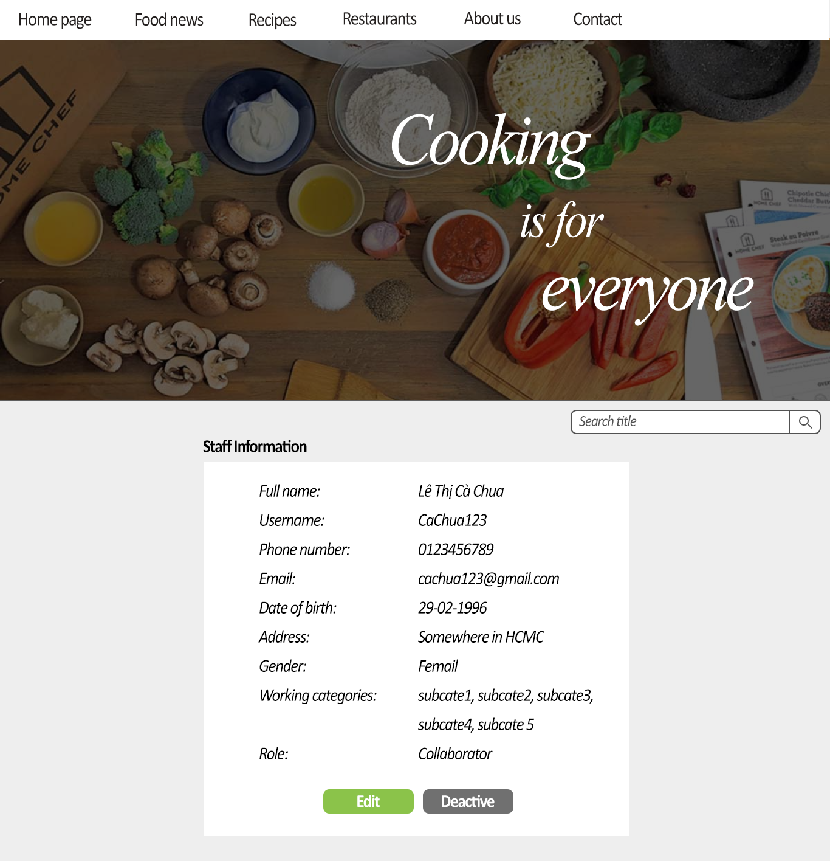

11

12

10

9

8

7

6

5

4

3

2

1

|  |  |  |  |  |  |  |
| --- | --- | --- | --- | --- | --- | --- |
| **No.** | **Name** | **Type** | **Validation** | **Event** | **Description** | **Status** |
| 1 | gridStaffDetail | Grid |  |  | Grid contains controls:2,3,4,5,6,7,8,9 date get from Staff table |  |
| 2 | lbFullName | Label |  |  | Staff full name |  |
| 3 | lbUsername | Label |  |  | Staff username |  |
| 4 | lbPhone | Label |  |  | Staff phone |  |
| 5 | lbEmail | Label |  |  | Staff email |  |
| 6 | lbDateOfBirth | Label |  |  | Staff date of birth |  |
| 7 | lbAddress | Label |  |  | Staff address |  |
| 8 | lbGender | Label |  |  | Staff gender |  |
| 9 | lbSubcategories | Label |  |  | Subcategories of staff |  |
| 10 | lbRole | Label |  |  | Staff role |  |
| 11 | btnEdit | Button |  | Click | Redirect to EditStaff page |  |
| 12 | btnDeactive | Button |  | Click | Appear a modal to confirm |  |

***14.18 editStaff.jsp (Ad, Man)***

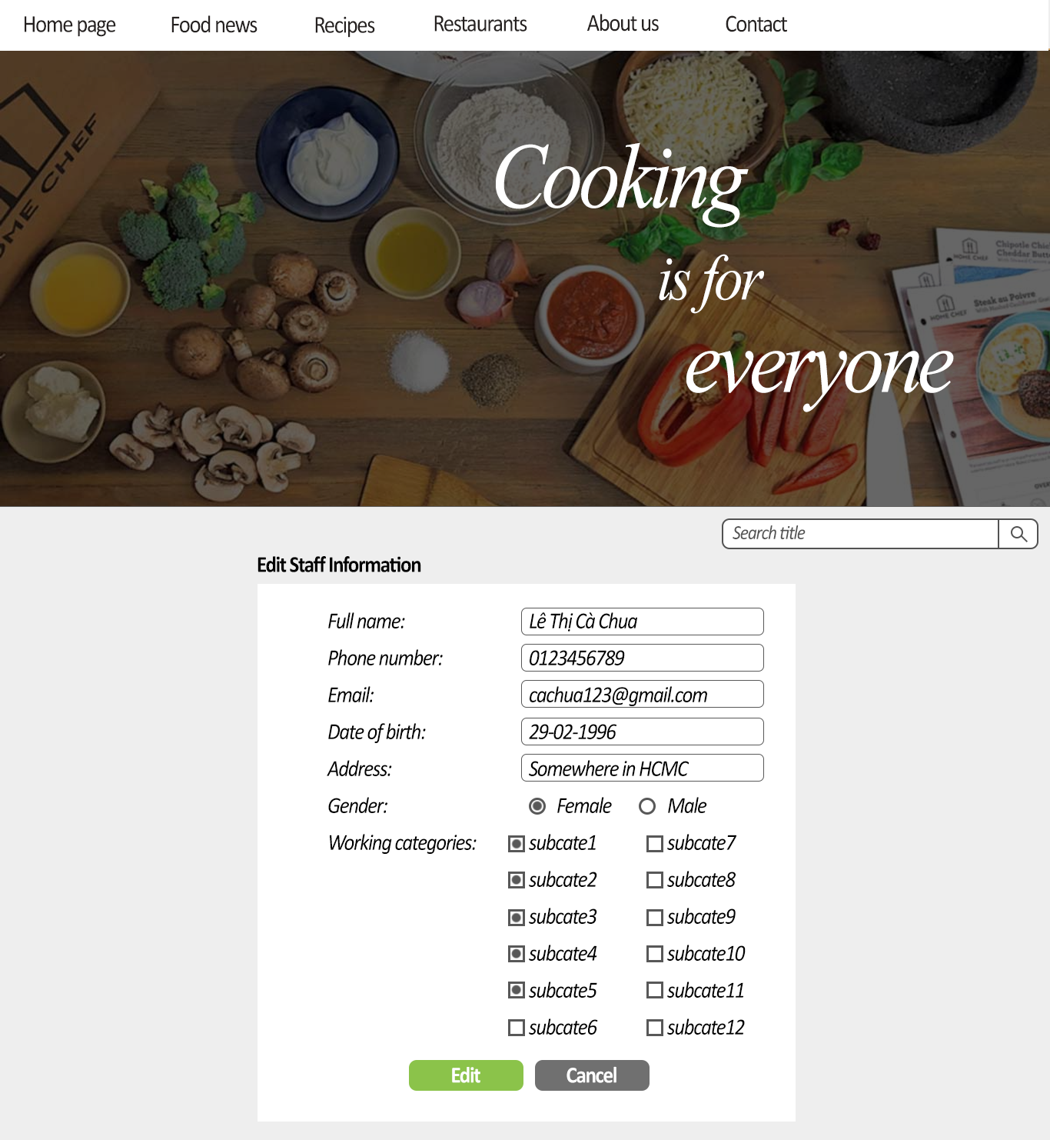

1

2

3

4

5

6

7

8

9

10

11

12

|  |  |  |  |  |  |  |
| --- | --- | --- | --- | --- | --- | --- |
| **No.** | **Name** | **Type** | **Validation** | **Event** | **Description** | **Status** |
| 1 | gridStaffDetail | Grid |  |  | Grid contains controls:2,3,4,5,6,7,8 date get from Staff table |  |
| 2 | txtFullName | Text field | Not null |  | Staff name |  |
| 3 | txtPhone | Text field | Not null |  | Staff phone |  |
| 4 | txtEmail | Text field | Not null |  | Staff email |  |
| 5 | txtDateOfBirth | Text field | Not null |  | Staff date of birth |  |
| 6 | txtAddress | Text field | Not null |  | Staff address |  |
| 7 | rdFemale | Radio button |  | Click | Gender selection |  |
| 8 | rdMale | Radio button |  | Click | Gender selection |  |
| 9 | chkListSubcategories | List | At least 1 checkbox is checked |  | List of Subcategories |  |
| 10 | chkBoxSubcategory | Checkbox |  | Click | Subcategory selection |  |
| 11 | btnEdit | Button |  | Click | Update staff information and redirect to InformationStaff page |  |
| 12 | btnCancel | Button |  | Click | Redirect to InformationStaff page |  |

***14.19 createStaff.jsp (Ad, Man)***

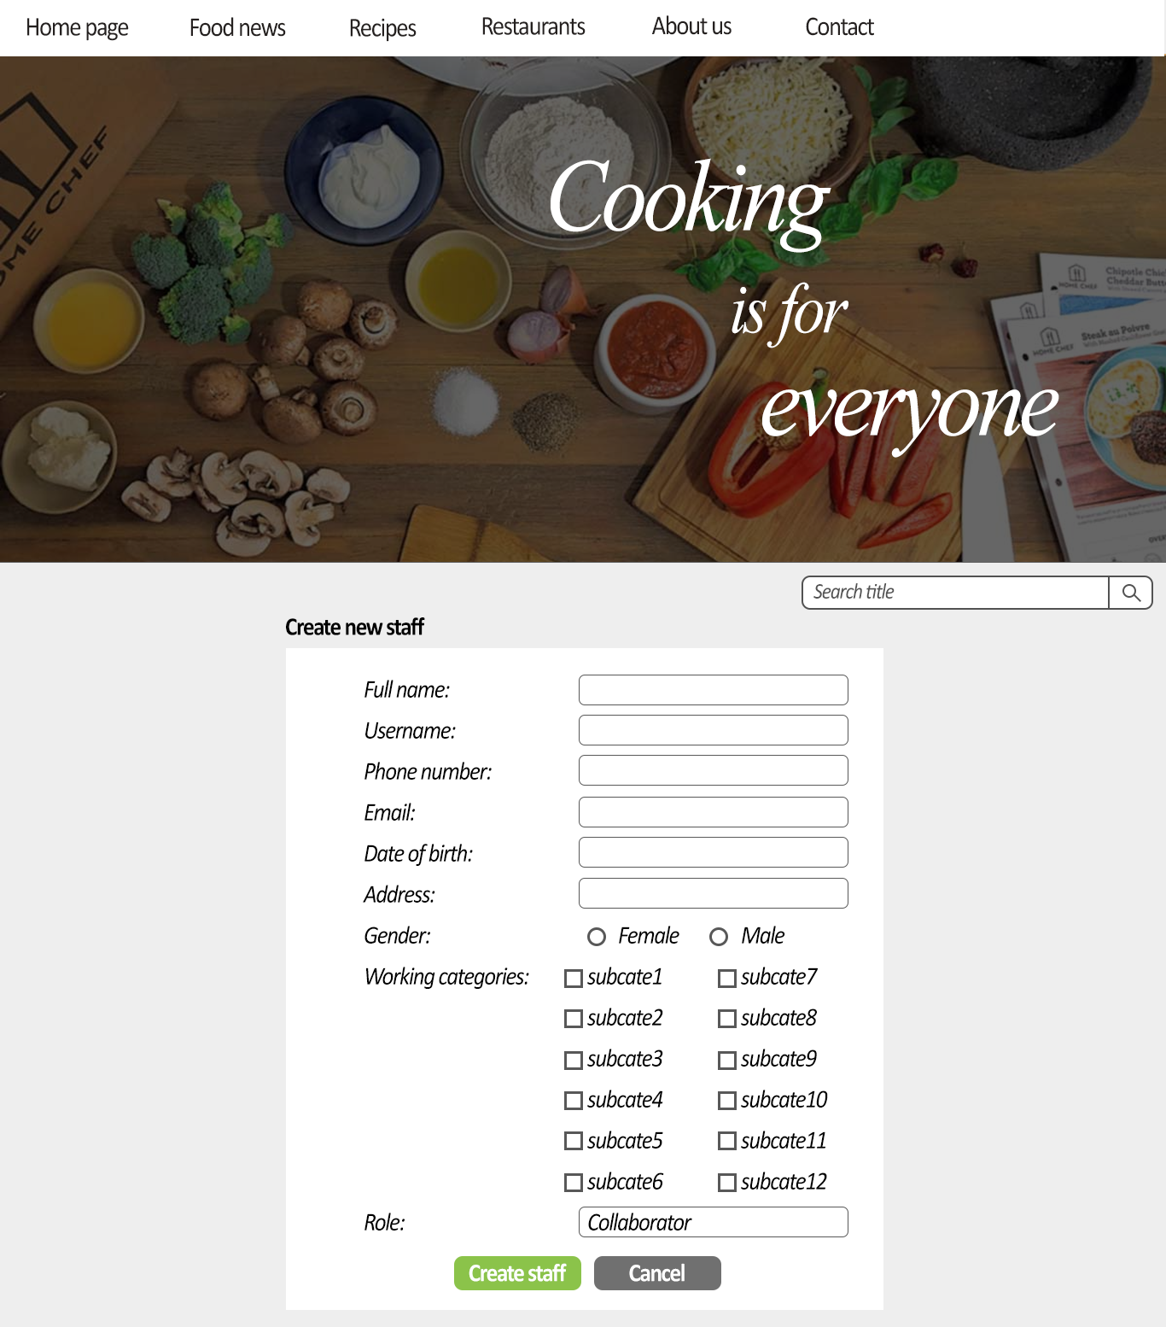

14

1

2

3

4

5

6

8

9

10

11

12

13

7

|  |  |  |  |  |  |  |
| --- | --- | --- | --- | --- | --- | --- |
| **No.** | **Name** | **Type** | **Validation** | **Event** | **Description** | **Status** |
| 1 | gridStaffDetail | Grid |  |  | Grid contains controls:2,3,4,5,6,7,8 date get from Staff table |  |
| 2 | txtFullName | Text field | Not null |  | Staff name |  |
| 3 | txtUsername | Text field | Not null |  | Staff username |  |
| 4 | txtPhone | Text field | Not null |  | Staff phone |  |
| 5 | txtEmail | Text field | Not null |  | Staff email |  |
| 6 | txtDateOfBirth | Text field | Not null |  | Staff date of birth |  |
| 7 | txtAddress | Text field | Not null |  | Staff address |  |
| 8 | rdFemale | Radio button |  | Click | Gender selection |  |
| 9 | rdMale | Radio button |  | Click | Gender selection |  |
| 10 | chkListSubcategories | List | At least 1 checkbox is checked |  | List of Subcategories |  |
| 11 | chkBoxSubcategory | Checkbox |  | Click | Subcategory selection |  |
| 12 | txtRole | Text field | Not null |  | Staff role |  |
| 13 | btnCreate | Button |  | Click | Create staff and add to system. Redirect to previous page |  |
| 14 | btnCancel | Button |  | Click | Redirect to InformationStaff page |  |

***14.12 editArticle.jsp***

***14.14 addSubCat.jsp (Ad)***

***14.15 modifySubCat.jsp (Ad)***

***14.16 totalPostByState.jsp (Ad)***

***14.17 listPostByView.jsp (Ad)***

**15. Report**

***15.1 Articles***

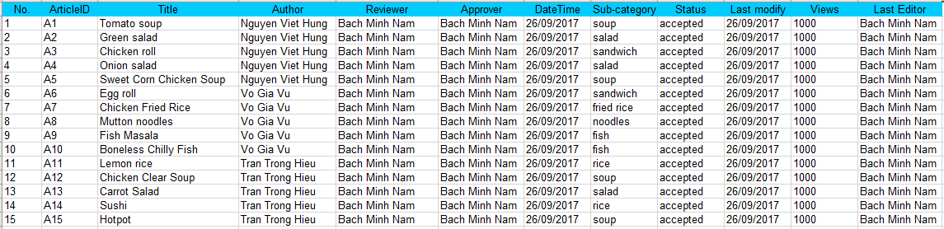

|  |  |
| --- | --- |
| **Report Resources** | |
| **Table name** | **Field name** |
| tbl_Article | ArticleID, Title, AuthorID, ReviewerID, ApproverID, DateTime, SubCategoryID, Status, LastModifiedDateTime, Views, LastEditorID |
| tbl_Staff | StaffID, Name |
| tbl_Subcategory | SubcategoryID, Name |

***15.2 Staffs***

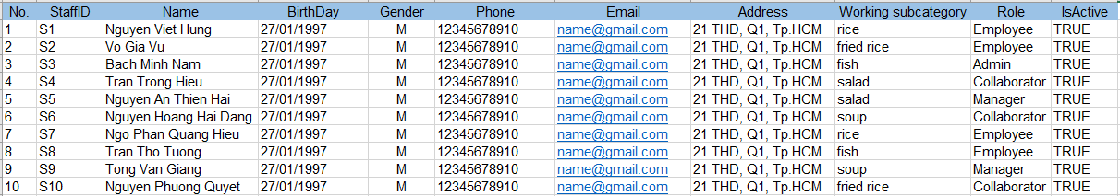

|  |  |
| --- | --- |
| **Report Resources** | |
| **Table name** | **Field name** |
| tbl_Staff | StaffID, Name, BirthDay, Gender, Phone, Email, Address, Phone, Role, IsActive |
| tbl_WorkingSubcategory | StaffID, SubcategoryID |
| tbl_Subcategory | SubcategoryID, Name |

**Task**

**Sheet**

**TASK SHEET**

|  |  |  |  |  |  |  |  |  |
| --- | --- | --- | --- | --- | --- | --- | --- | --- |
| **Project Ref. No 1** | | **Project Title** | **Activity Plan Prepared By** | **Date of Preparation of Activity Plan** | | | | |
| **Sr. No** | **Task** |  |  | **Start Date** | **End Date** | **Actual Days** | **Member’s name** | **Status** |
| **CRS document** | | | | | | | | |
| 1 | Introduction | MasterCook | Nguyen Viet Hung | 09/07/2017 | 09/07/2017 | 1 | All of Team | FINISH |
| 2 | Existing Scenario | MasterCook | Nguyen Viet Hung | 09/07/2017 | 09/07/2017 | 1 | All of Team | FINISH |
| 3 | Customer Requirement Specification | MasterCook | Nguyen Viet Hung | 09/07/2017 | 09/13/2017 | 4 | All of Team | FINISH |
| 4 | Functional Requirement Specification | MasterCook | Nguyen Viet Hung | 09/13/2017 | 09/15/2017 | 3 | All of Team | FINISH |
| 5 | System Requirements | MasterCook | Nguyen Viet Hung | 09/15/2017 | 09/15/2017 | 1 | All of Team | FINISH |
| 6 | Development Software | MasterCook | Nguyen Viet Hung | 09/15/2017 | 09/15/2017 | 1 | All of Team | FINISH |
| **Use Case and Sequence Diagrams** | | | | | | | | |
| 7 | View Pending posts | MasterCook | Nguyen Viet Hung | 09/14/2017 | 09/17/2017 | 4 | Nguyen Viet Hung | FINISH |
| 8 | Edit posts | MasterCook | Nguyen Viet Hung | 09/14/2017 | 09/17/2017 | 4 | Nguyen Viet Hung | FINISH |
| 9 | Approve posts | MasterCook | Nguyen Viet Hung | 09/14/2017 | 09/17/2017 | 4 | Nguyen Viet Hung | FINISH |
| 10 | Reject posts | MasterCook | Nguyen Viet Hung | 09/14/2017 | 09/17/2017 | 4 | Nguyen Viet Hung | FINISH |
| 11 | View productivity of collaborator | MasterCook | Nguyen Viet Hung | 09/14/2017 | 09/17/2017 | 4 | Nguyen Viet Hung | FINISH |
| 12 | View productivity of employee | MasterCook | Nguyen Viet Hung | 09/14/2017 | 09/17/2017 | 4 | Nguyen Viet Hung | FINISH |
| 13 | View information and deactivated staff | MasterCook | Nguyen Viet Hung | 09/14/2017 | 09/17/2017 | 4 | Nguyen Viet Hung | FINISH |
| 14 | Create new staff | MasterCook | Nguyen Viet Hung | 09/14/2017 | 09/17/2017 | 4 | Nguyen Viet Hung | FINISH |
| 15 | Search Posts | MasterCook | Nguyen Viet Hung | 09/14/2017 | 09/17/2017 | 4 | Tran Trong Hieu | FINISH |
| 16 | View post’s detail | MasterCook | Nguyen Viet Hung | 09/14/2017 | 09/17/2017 | 4 | Tran Trong Hieu | FINISH |
| 17 | View same category posts | MasterCook | Nguyen Viet Hung | 09/14/2017 | 09/17/2017 | 4 | Tran Trong Hieu | FINISH |
| 18 | View comments of post | MasterCook | Nguyen Viet Hung | 09/14/2017 | 09/17/2017 | 4 | Tran Trong Hieu | FINISH |
| 19 | Select category | MasterCook | Nguyen Viet Hung | 09/14/2017 | 09/17/2017 | 4 | Tran Trong Hieu | FINISH |
| 20 | Add category | MasterCook | Nguyen Viet Hung | 09/14/2017 | 09/17/2017 | 4 | Tran Trong Hieu | FINISH |
| 21 | Modify category | MasterCook | Nguyen Viet Hung | 09/14/2017 | 09/17/2017 | 4 | Tran Trong Hieu | FINISH |
| 22 | View total post | MasterCook | Nguyen Viet Hung | 09/14/2017 | 09/17/2017 | 4 | Tran Trong Hieu | FINISH |
| 22 | See list of post by view number | MasterCook | Nguyen Viet Hung | 09/14/2017 | 09/17/2017 | 4 | Tran Trong Hieu | FINISH |
| 23 | Post articles | MasterCook | Nguyen Viet Hung | 09/14/2017 | 09/17/2017 | 4 | Vo Gia Vu | FINISH |
| 24 | View own articles | MasterCook | Nguyen Viet Hung | 09/14/2017 | 09/17/2017 | 4 | Vo Gia Vu | FINISH |
| 25 | Edit own articles | MasterCook | Nguyen Viet Hung | 09/14/2017 | 09/17/2017 | 4 | Vo Gia Vu | FINISH |
| 26 | Delete comments | MasterCook | Nguyen Viet Hung | 09/14/2017 | 09/17/2017 | 4 | Vo Gia Vu | FINISH |
| 27 | Login | MasterCook | Nguyen Viet Hung | 09/14/2017 | 09/17/2017 | 4 | Vo Gia Vu | FINISH |
| 28 | Logout | MasterCook | Nguyen Viet Hung | 09/14/2017 | 09/17/2017 | 4 | Vo Gia Vu | FINISH |
| 29 | Change password | MasterCook | Nguyen Viet Hung | 09/14/2017 | 09/17/2017 | 4 | Tran Trong Hieu | FINISH |
| **ERD** | | | | | | | | |
| 30 | Conceptual | MasterCook | Nguyen Viet Hung | 09/14/2017 | 09/17/2017 | 4 | All of Team | FINISH |
| 31 | Table | MasterCook | Nguyen Viet Hung | 09/14/2017 | 09/17/2017 | 4 | All of Team | FINISH |
| 32 | Database Relationship | MasterCook | Nguyen Viet Hung | 09/14/2017 | 09/17/2017 | 4 | All of Team | FINISH |
| 33 | Table Definition | MasterCook | Nguyen Viet Hung | 09/14/2017 | 09/17/2017 | 4 | All of Team | FINISH |
| **GUI** | | | | | | | | |
| 33 | Home | MasterCook | Nguyen Viet Hung | 06/29/2008 | 07/02/2008 | 4 | All of Team | FINISH |
| 34 | Display advertisement on Home page | MasterCook | Nguyen Viet Hung | 06/29/2008 | 07/02/2008 | 4 | Tran Thanh Duy | FINISH |
| 35 | login | MasterCook | Nguyen Viet Hung | 06/29/2008 | 07/02/2008 | 4 | Pham Viet Hien | FINISH |
| 36 | registerPolicy | MasterCook | Nguyen Viet Hung | 06/29/2008 | 07/02/2008 | 4 | Pham Viet Hien | FINISH |
| 37 | sendEnquiry | MasterCook | Nguyen Viet Hung | 06/29/2008 | 07/02/2008 | 4 | Nguyen Viet Hung | FINISH |
|  | updateProfile | MasterCook | Nguyen Viet Hung | 06/29/2008 | 07/02/2008 | 4 | Pham Viet Hien | FINISH |
|  | buyGoldBuyerPackage | MasterCook | Nguyen Viet Hung | 06/29/2008 | 07/02/2008 | 4 | Pham Viet Hien | FINISH |
|  | listOfSearchQueries | MasterCook | Nguyen Viet Hung | 06/29/2008 | 07/02/2008 | 4 | Pham Viet Hien | FINISH |
|  | listOfShortcuts | MasterCook | Nguyen Viet Hung | 06/29/2008 | 07/02/2008 | 4 | Nguyen Hai Dang | FINISH |
|  | listOfProperties | MasterCook | Nguyen Viet Hung | 06/29/2008 | 07/02/2008 | 4 | Tran Thanh Duy | FINISH |
|  | activateProperty | MasterCook | Nguyen Viet Hung | 06/29/2008 | 07/02/2008 | 4 | Tran Thanh Duy | FINISH |
|  | postProperty | MasterCook | Nguyen Viet Hung | 06/29/2008 | 07/02/2008 | 4 | Tran Thanh Duy | FINISH |
|  | positionPanels | MasterCook | Nguyen Viet Hung | 06/29/2008 | 07/02/2008 | 4 | Tran Thanh Duy | FINISH |
|  | modifyProperty | MasterCook | Nguyen Viet Hung | 06/29/2008 | 07/02/2008 | 4 | Tran Thanh Duy | FINISH |
|  | propertyDetail | MasterCook | Nguyen Viet Hung | 06/29/2008 | 07/02/2008 | 4 | Nguyen Hai Dang  & Tran Thanh Duy | FINISH |
|  | Loan information | MasterCook | Nguyen Viet Hung | 06/29/2008 | 07/02/2008 | 4 | Nguyen Hai Dang | FINISH |
|  | view Google Map | MasterCook | Nguyen Viet Hung | 06/29/2008 | 07/02/2008 | 4 | Nguyen Hai Dang | FINISH |
|  | Choose Google Map for Property | MasterCook | Nguyen Viet Hung | 06/29/2008 | 07/02/2008 | 4 | Nguyen Hai Dang | FINISH |
|  | Choose position for property | MasterCook | Nguyen Viet Hung | 06/29/2008 | 07/02/2008 | 4 | Tran Thanh Duy | FINISH |
|  | sendMessageToSeller | MasterCook | Nguyen Viet Hung | 06/29/2008 | 07/02/2008 | 4 | Nguyen Hai Dang | FINISH |
|  | search | MasterCook | Nguyen Viet Hung | 06/29/2008 | 07/02/2008 | 4 | Pham Viet Hien | FINISH |
|  | faq | MasterCook | Nguyen Viet Hung | 06/29/2008 | 07/02/2008 | 4 | Nguyen Hai Dang | FINISH |
|  | adminHome | MasterCook | Nguyen Viet Hung | 06/29/2008 | 07/02/2008 | 4 | Nguyen Viet Hung | FINISH |
|  | loginAdmin | MasterCook | Nguyen Viet Hung | 06/29/2008 | 07/02/2008 | 4 | Nguyen Viet Hung | FINISH |
|  | listOfCustomers | MasterCook | Nguyen Viet Hung | 06/29/2008 | 07/02/2008 | 4 | Nguyen Viet Hung | FINISH |
|  | customerDetail | MasterCook | Nguyen Viet Hung | 06/29/2008 | 07/02/2008 | 4 | Nguyen Viet Hung | FINISH |
|  | updateAdvsPrice | MasterCook | Nguyen Viet Hung | 06/29/2008 | 07/02/2008 | 4 | Nguyen Viet Hung | FINISH |
|  | listOfDirectories | MasterCook | Nguyen Viet Hung | 06/29/2008 | 07/02/2008 | 4 | Nguyen Viet Hung | FINISH |
|  | addDirectory | MasterCook | Nguyen Viet Hung | 06/29/2008 | 07/02/2008 | 4 | Nguyen Viet Hung | FINISH |
|  | modifyDirectory | MasterCook | Nguyen Viet Hung | 06/29/2008 | 07/02/2008 | 4 | Nguyen Viet Hung | FINISH |
|  | listOfDirectoryCategories | MasterCook | Nguyen Viet Hung | 06/29/2008 | 07/02/2008 | 4 | Nguyen Viet Hung | FINISH |
|  | addDirectoryCategory | MasterCook | Nguyen Viet Hung | 06/29/2008 | 07/02/2008 | 4 | Nguyen Viet Hung | FINISH |
|  | modifyDirectoryCategory | MasterCook | Nguyen Viet Hung | 06/29/2008 | 07/02/2008 | 4 | Nguyen Viet Hung | FINISH |
|  | listOfBanks | MasterCook | Nguyen Viet Hung | 06/29/2008 | 07/02/2008 | 4 | Nguyen Hai Dang | FINISH |
|  | addBank | MasterCook | Nguyen Viet Hung | 06/29/2008 | 07/02/2008 | 4 | Nguyen Hai Dang | FINISH |
|  | modifyBank | MasterCook | Nguyen Viet Hung | 06/29/2008 | 07/02/2008 | 4 | Nguyen Hai Dang | FINISH |
|  | listOfFAQs | MasterCook | Nguyen Viet Hung | 06/29/2008 | 07/02/2008 | 4 | Nguyen Hai Dang | FINISH |
|  | addFAQ | MasterCook | Nguyen Viet Hung | 06/29/2008 | 07/02/2008 | 4 | Nguyen Hai Dang | FINISH |
|  | modifyFAQ | MasterCook | Nguyen Viet Hung | 06/29/2008 | 07/02/2008 | 4 | Nguyen Hai Dang | FINISH |
|  | listOfAdministrators | MasterCook | Nguyen Viet Hung | 06/29/2008 | 07/02/2008 | 4 | Nguyen Viet Hung | FINISH |
|  | addAdministrator | MasterCook | Nguyen Viet Hung | 06/29/2008 | 07/02/2008 | 4 | Nguyen Viet Hung | FINISH |
|  | report | MasterCook | Nguyen Viet Hung | 06/29/2008 | 07/02/2008 | 4 | All of Team | FINISH |
|  | changePassowrd | MasterCook | Nguyen Viet Hung | 06/29/2008 | 07/02/2008 | 4 | Nguyen Viet Hung | FINISH |
| **Report** | | | | | | | | |
| 106 | reportCustomers | MasterCook | Nguyen Viet Hung | 06/29/2008 | 07/02/2008 | 4 | Pham Viet Hien | FINISH |
| 107 | reportProperties | MasterCook | Nguyen Viet Hung | 06/29/2008 | 07/02/2008 | 4 | Tran Thanh Duy | FINISH |
| 108 | reportBanks | MasterCook | Nguyen Viet Hung | 06/29/2008 | 07/02/2008 | 4 | Nguyen Hai Dang | FINISH |
| 109 | reportDirectories | MasterCook | Nguyen Viet Hung | 06/29/2008 | 07/02/2008 | 4 | Nguyen Viet Hung | FINISH |
| **Permission Security** | | | | | | | | |
| 110 | Home page | MasterCook | Nguyen Viet Hung | 06/29/2008 | 07/02/2008 | 4 | Nguyen Viet Hung | FINISH |
| 111 | Admin page | MasterCook | Nguyen Viet Hung | 06/29/2008 | 07/02/2008 | 4 | Nguyen Viet Hung | FINISH |
| **Task sheet** | | | | | | | | |
| 112 | Task sheet | MasterCook | Nguyen Viet Hung | 09/21/2017 | 07/02/2008 | 1 | Tran Trong Hieu | FINISH |